Create and Manage Purchase entries in Runonweb

Go to runonweb.com

1. Introduction
In this tutorial, you will learn how to create, update, and cancel a Purchase, as well as generate an e-way bill for the Purchase.

2. Purchase Menu
Select the Purchase menu to open the Purchase list screen.
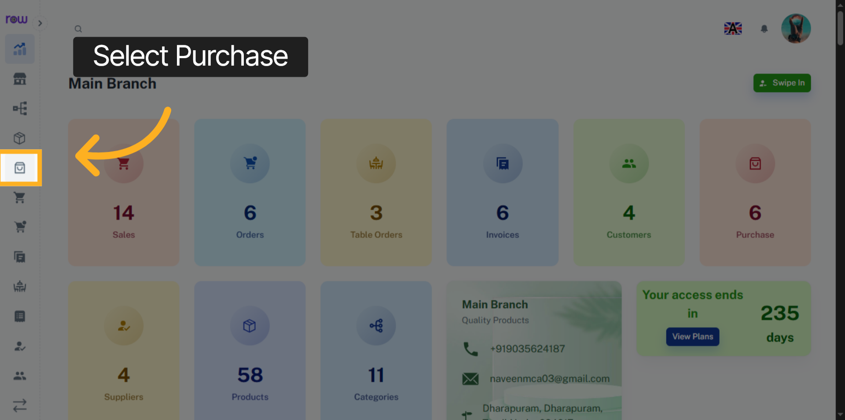

3. New Purchase Button
Click the New Purchase button to start creating a purchase.
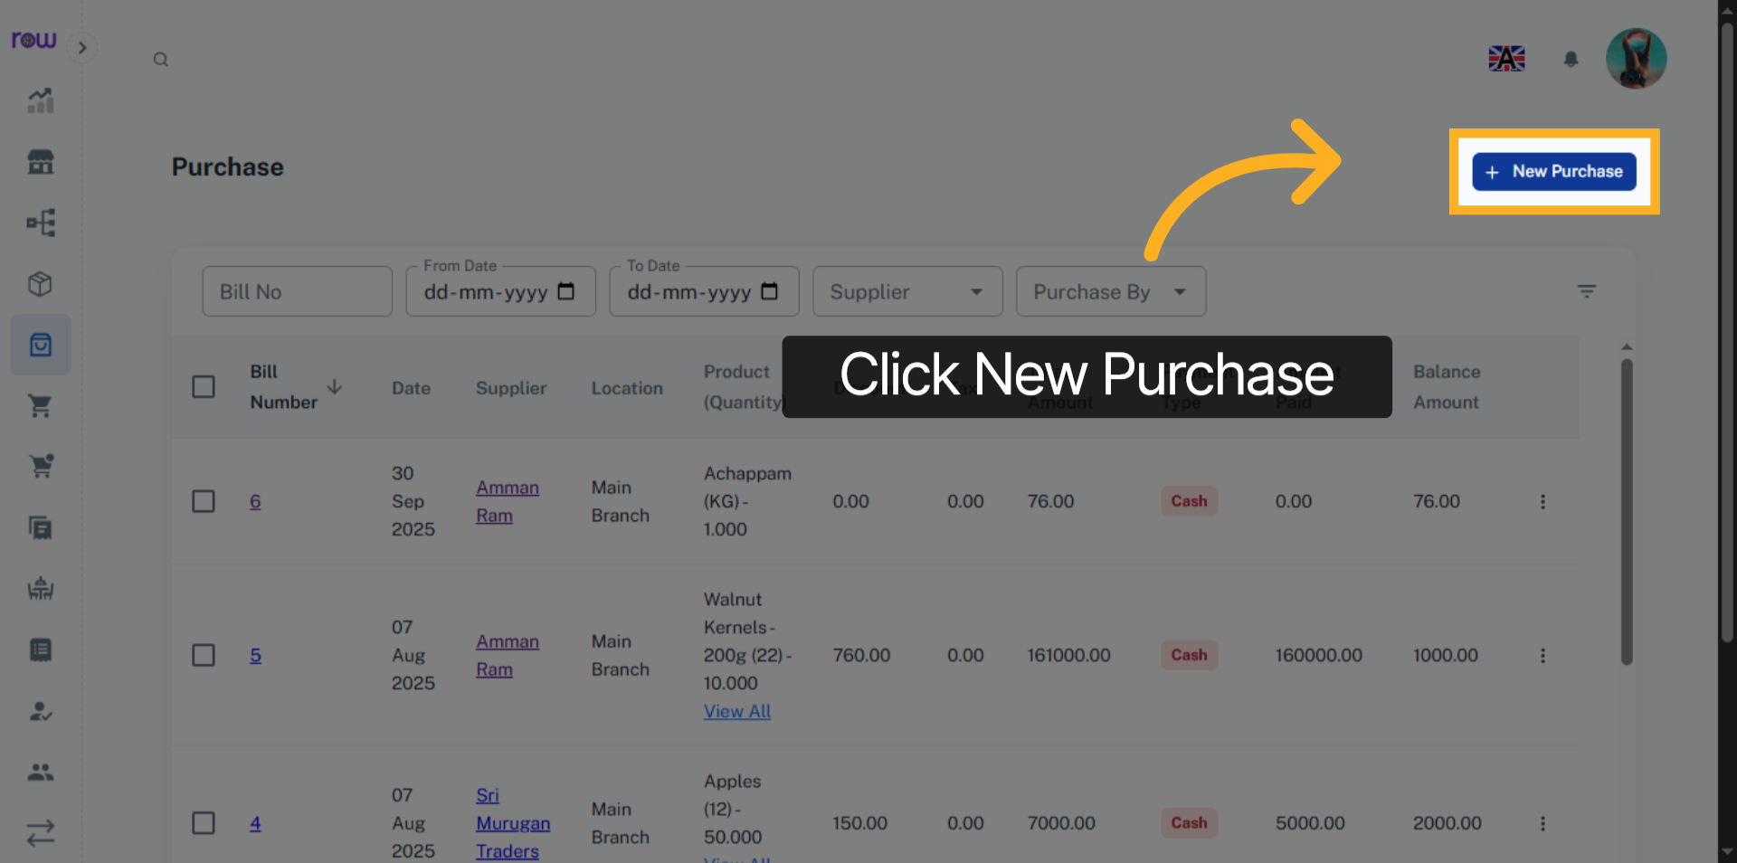

4. New Purchase
Purchase date, Invoice date, Purchase by and Location are already filled in. You can update them if needed.
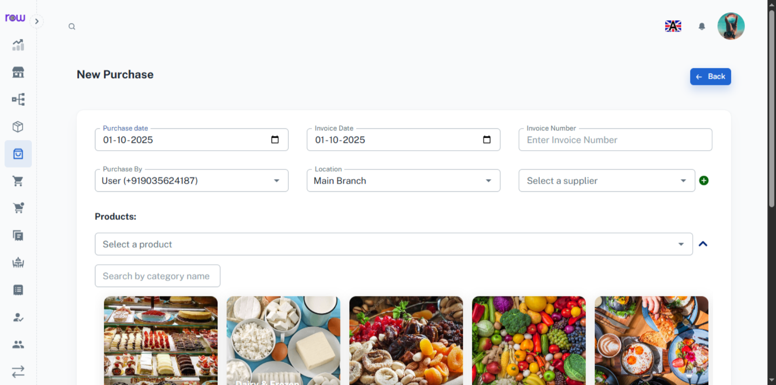

5. Invoice Number
Enter Invoice Number If available
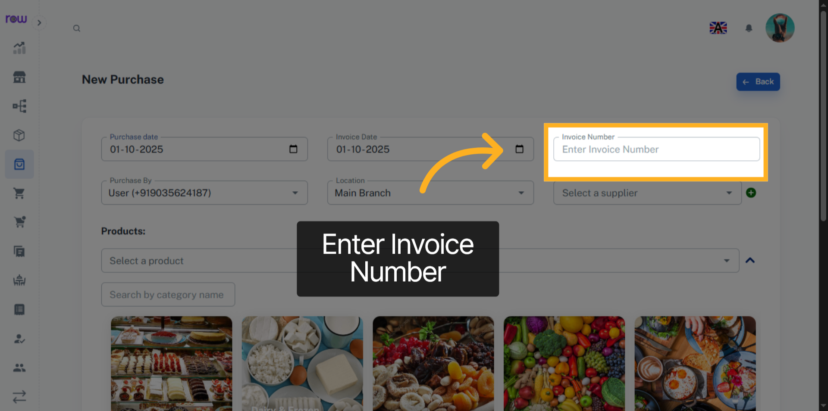

6. Select Supplier
Search and select an existing Supplier.
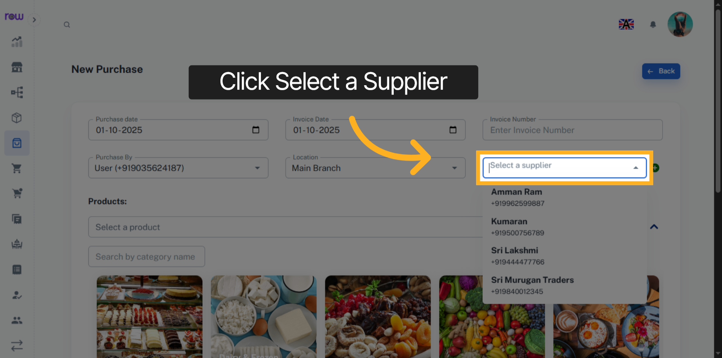

7. Create new Supplier
Click + icon to add a new Supplier
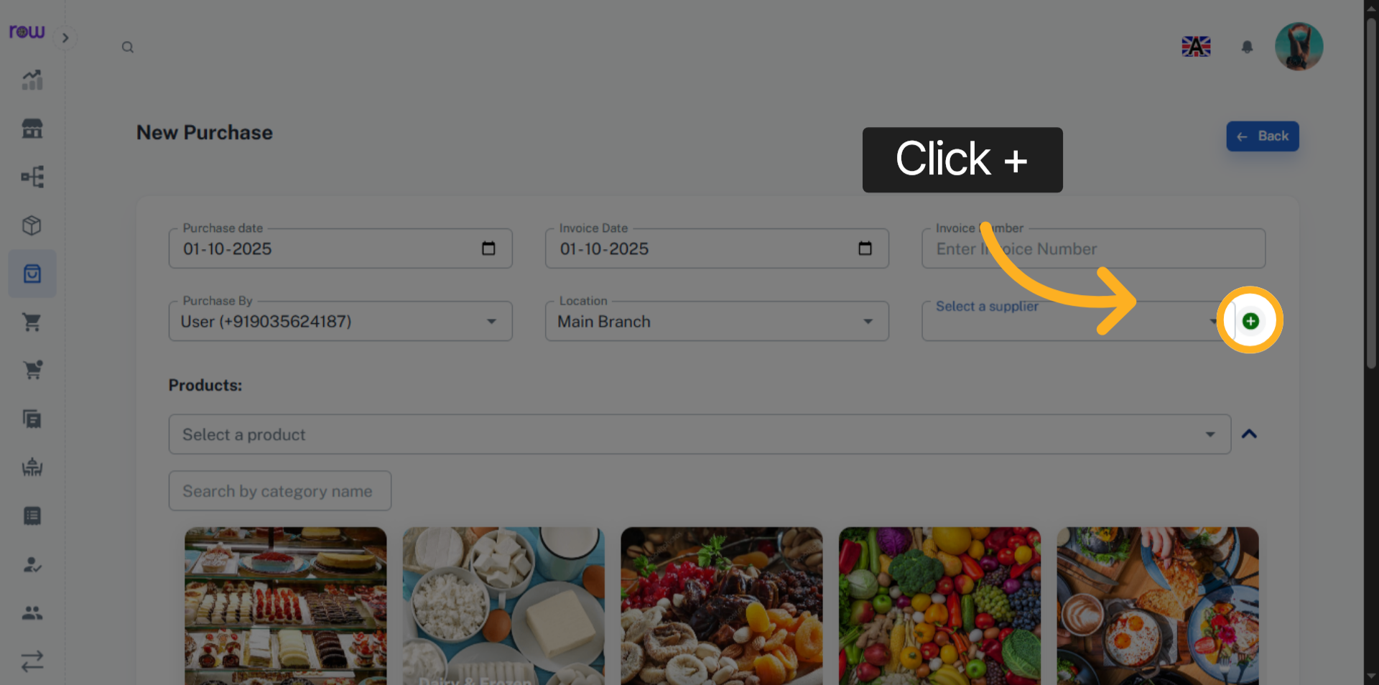

8. New Supplier Page
Enter the new Supplier details and click Add to save and select the Supplier.
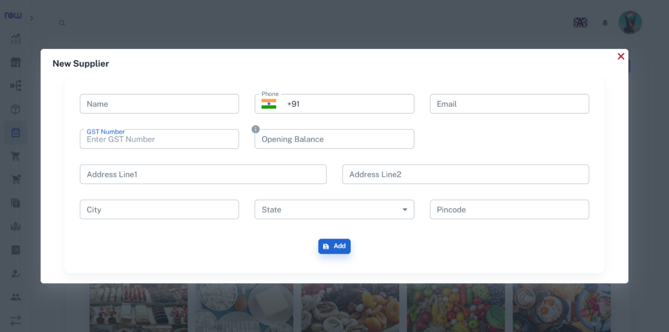

9. Select a product
Select a product from the dropdown. You can search by product name or code.
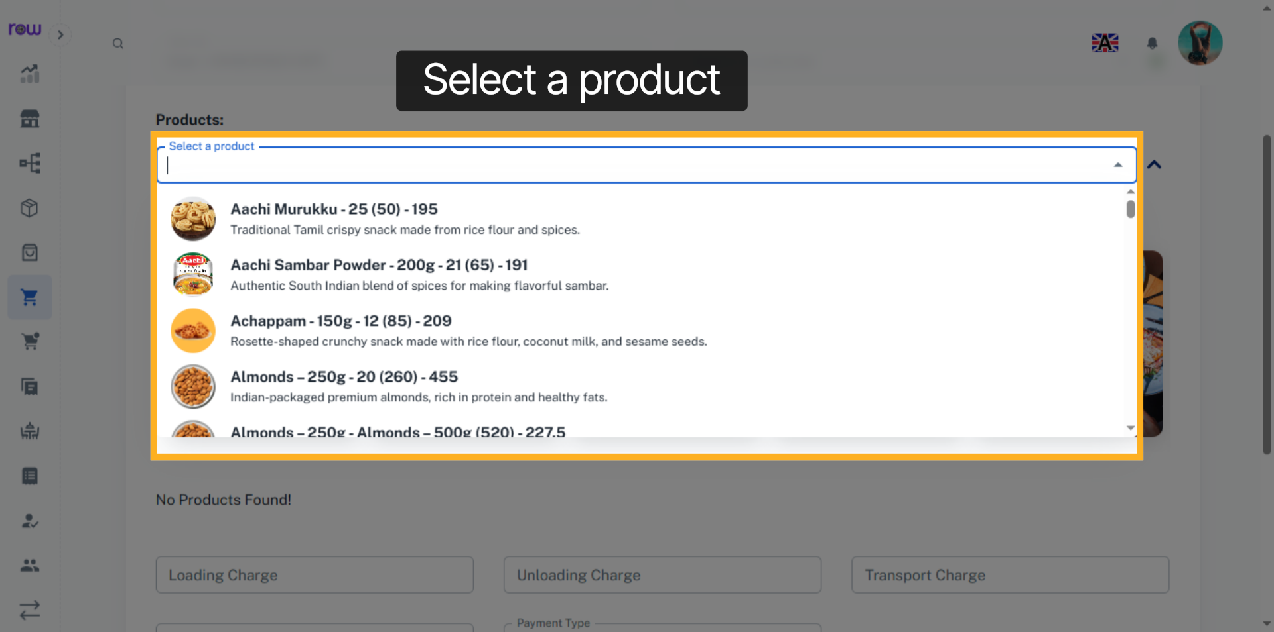

10. Product Selection Dropdown
Or click the arrow to find a product by its category.
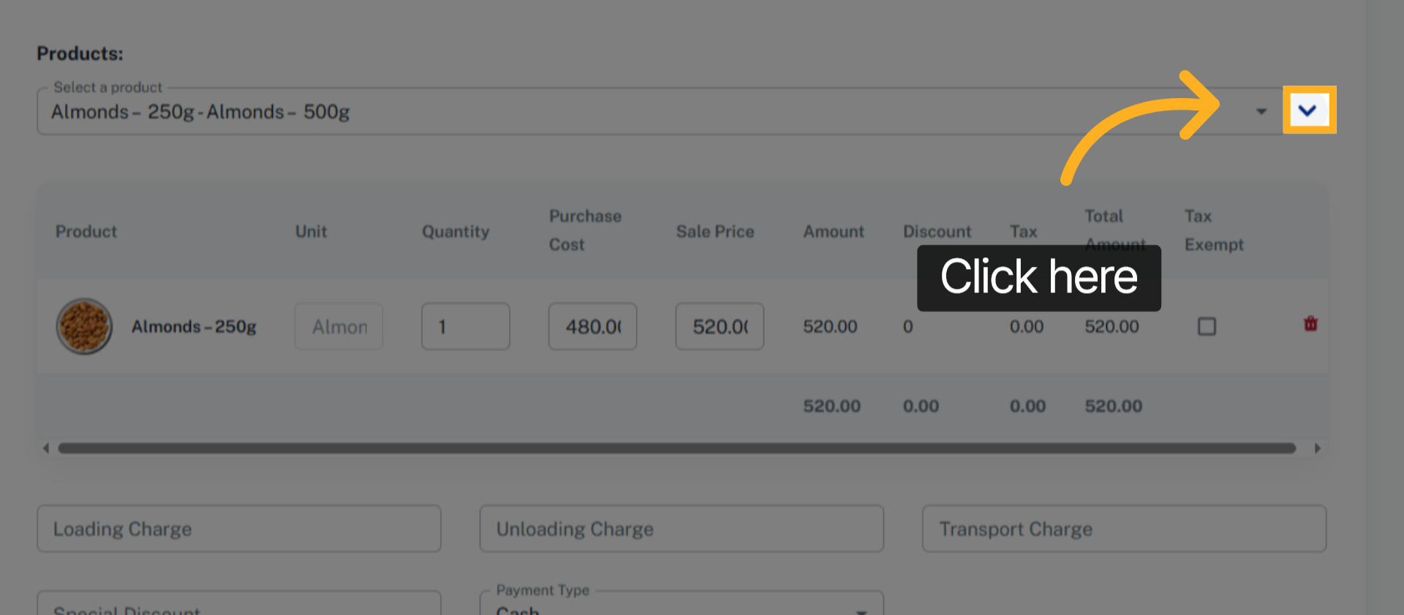

11. Select the product category
Select the product by its category
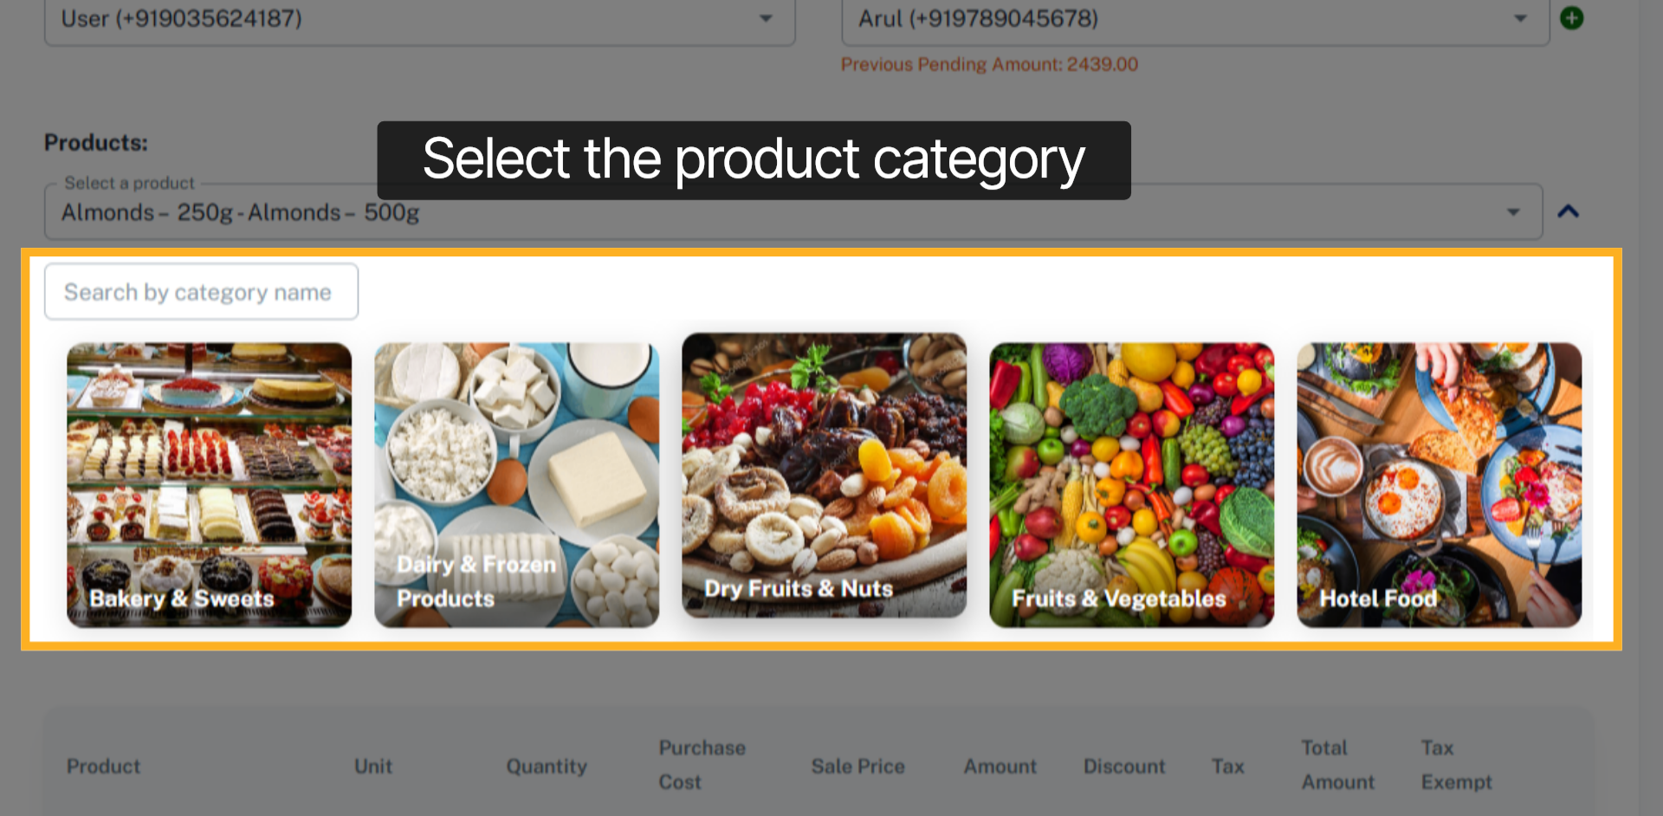

12. Select Product
Select product.
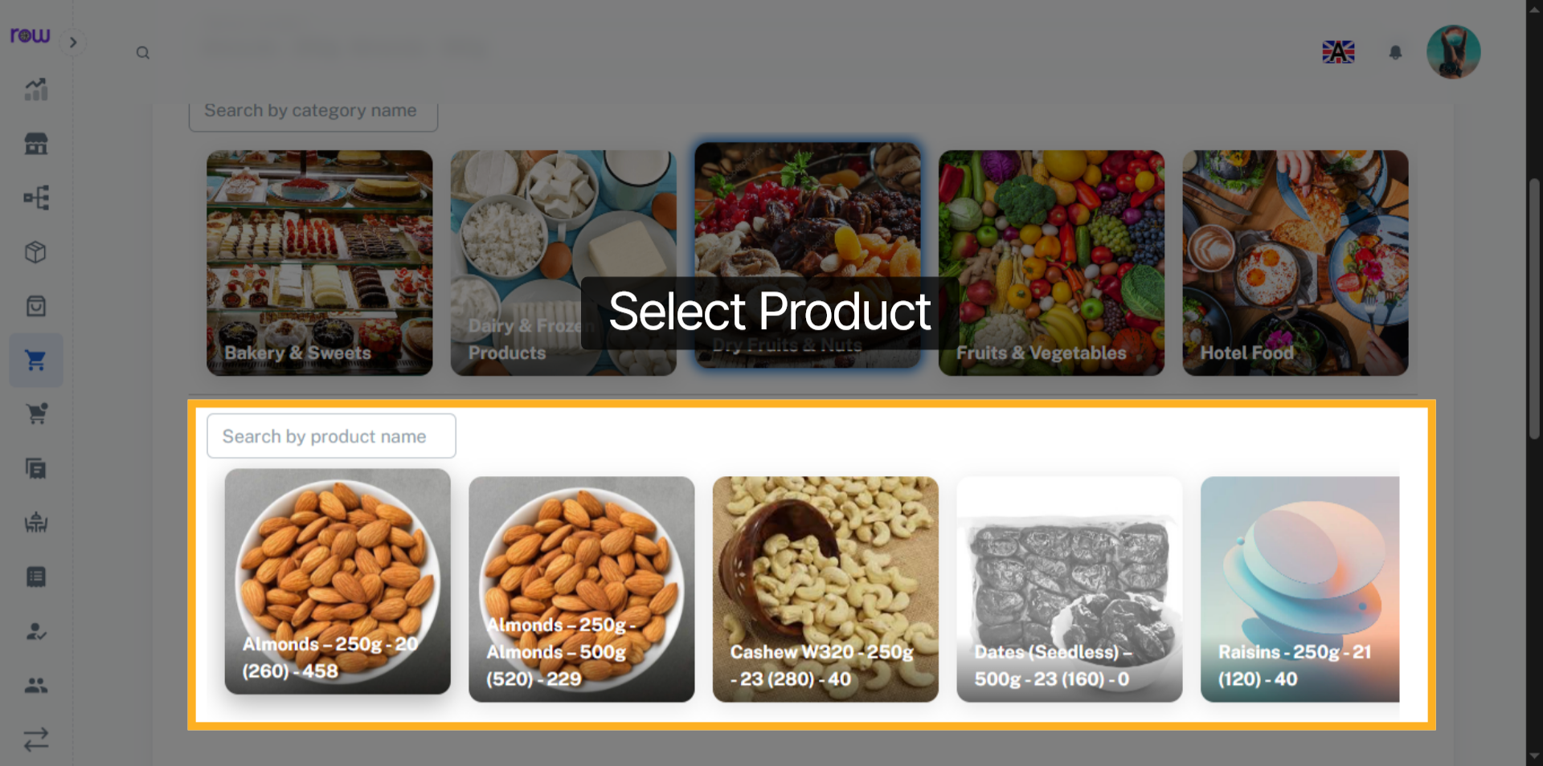

13. Selected Product List
After product selection you can update the quantity, Purchase cost and Sale price of the products.
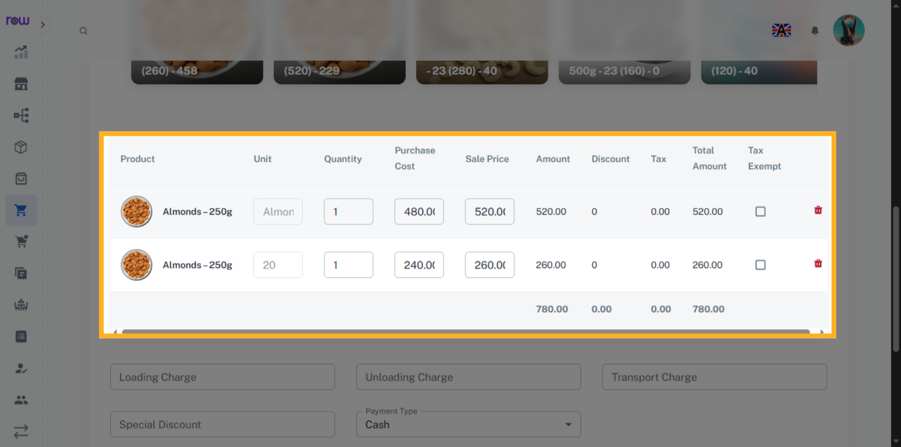

14. Tax Exempt Checkbox
Select the checkbox to exempt the tax for a product.
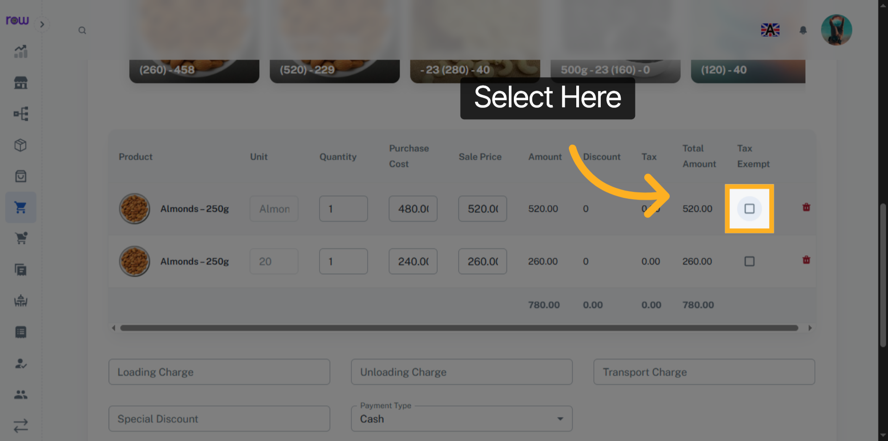

15. Other Optional Fields
Enter loading charge, unloading charge, transport charge and Special discount if applicable.
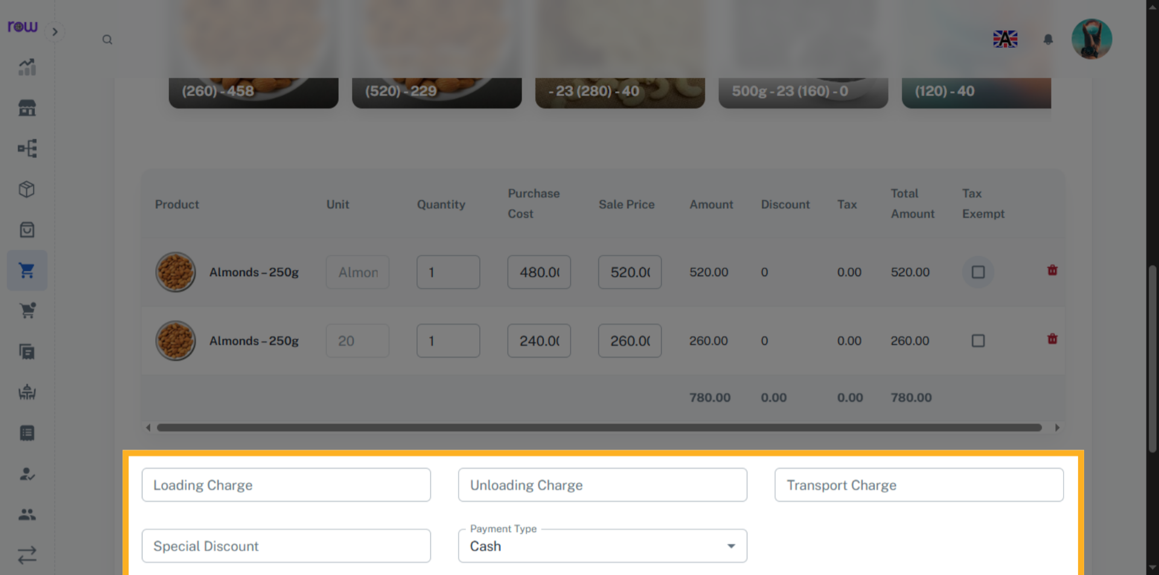

16. Round Off
If the total value has decimal points, you can round it off.
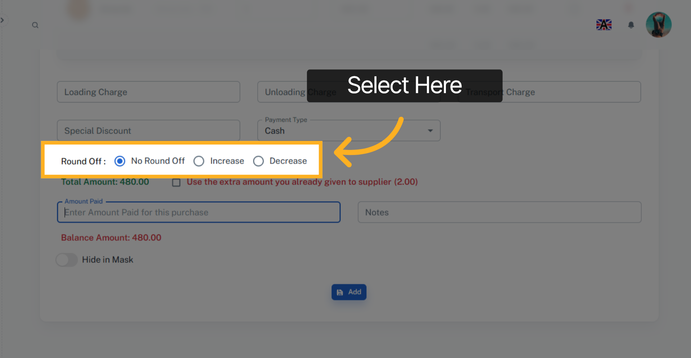

17. Amount Paid
Enter the amount Paid to the Supplier.
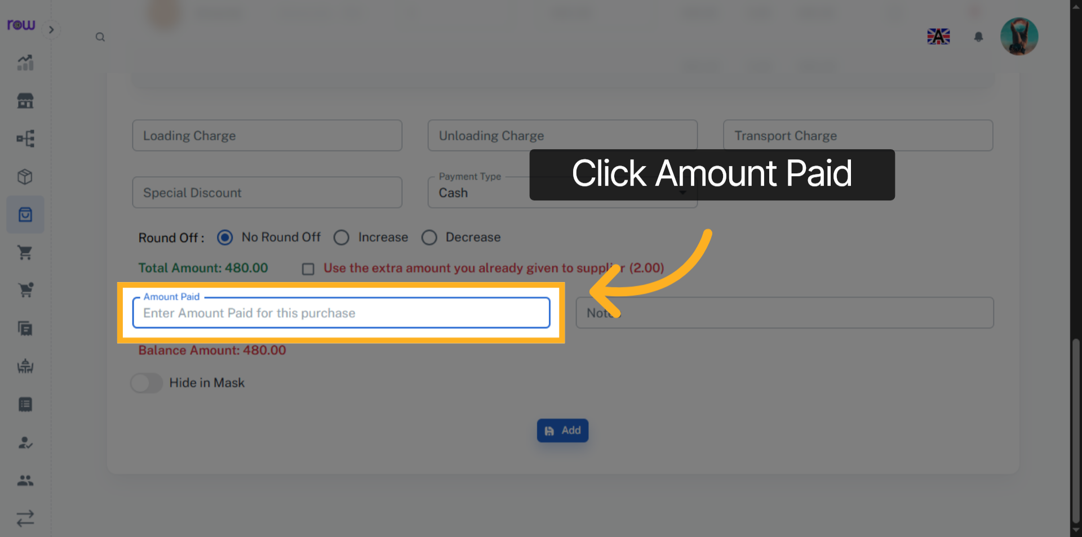

18. Add
Click "Add" to create the Purchase.
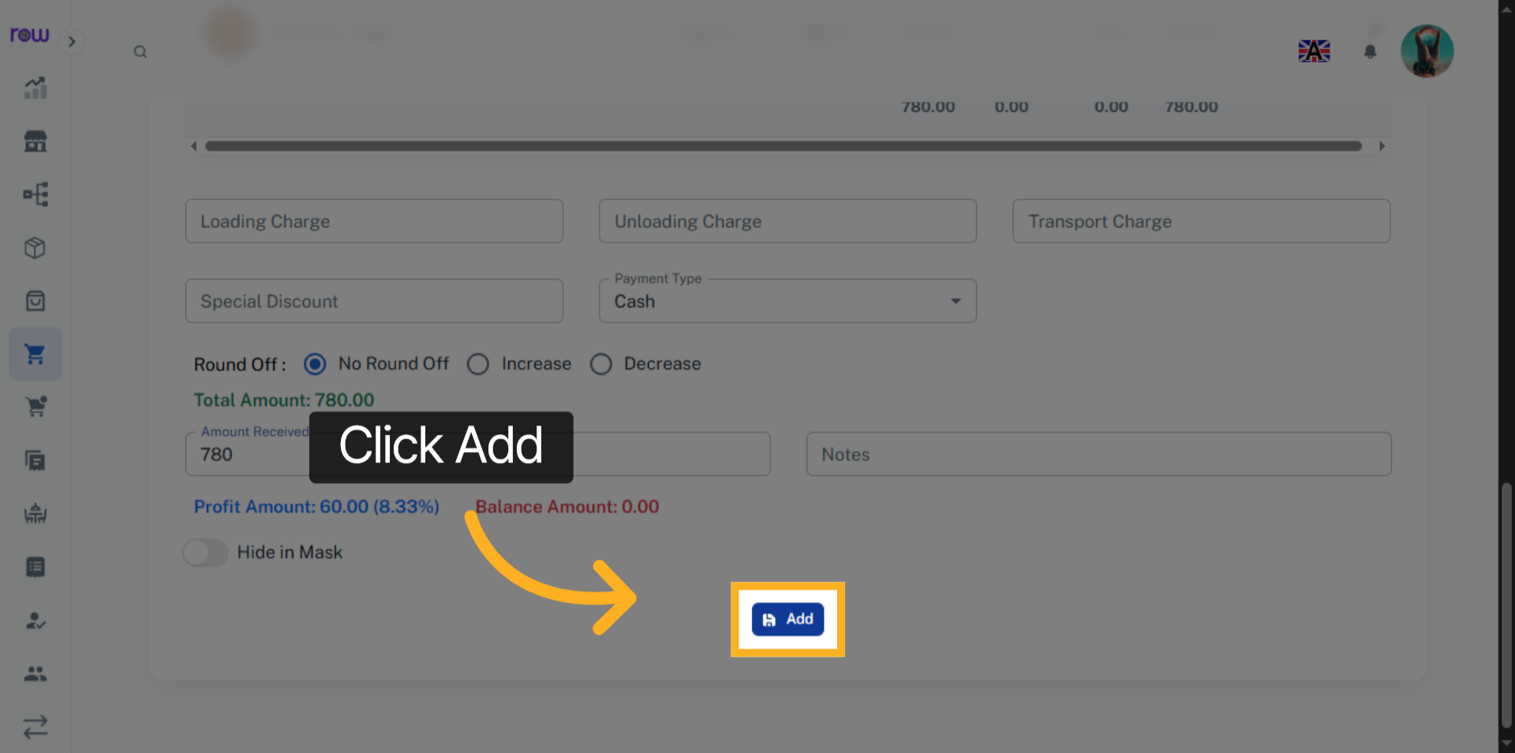

19. Purchase List
You will be redirected to the Purchase list screen after the Purchase is successfully created.
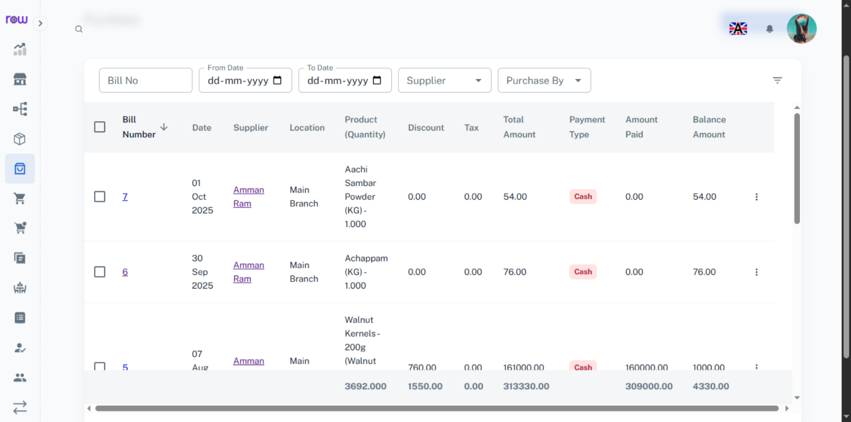

20. Bill Number
Click the bill number to edit the Purchase.
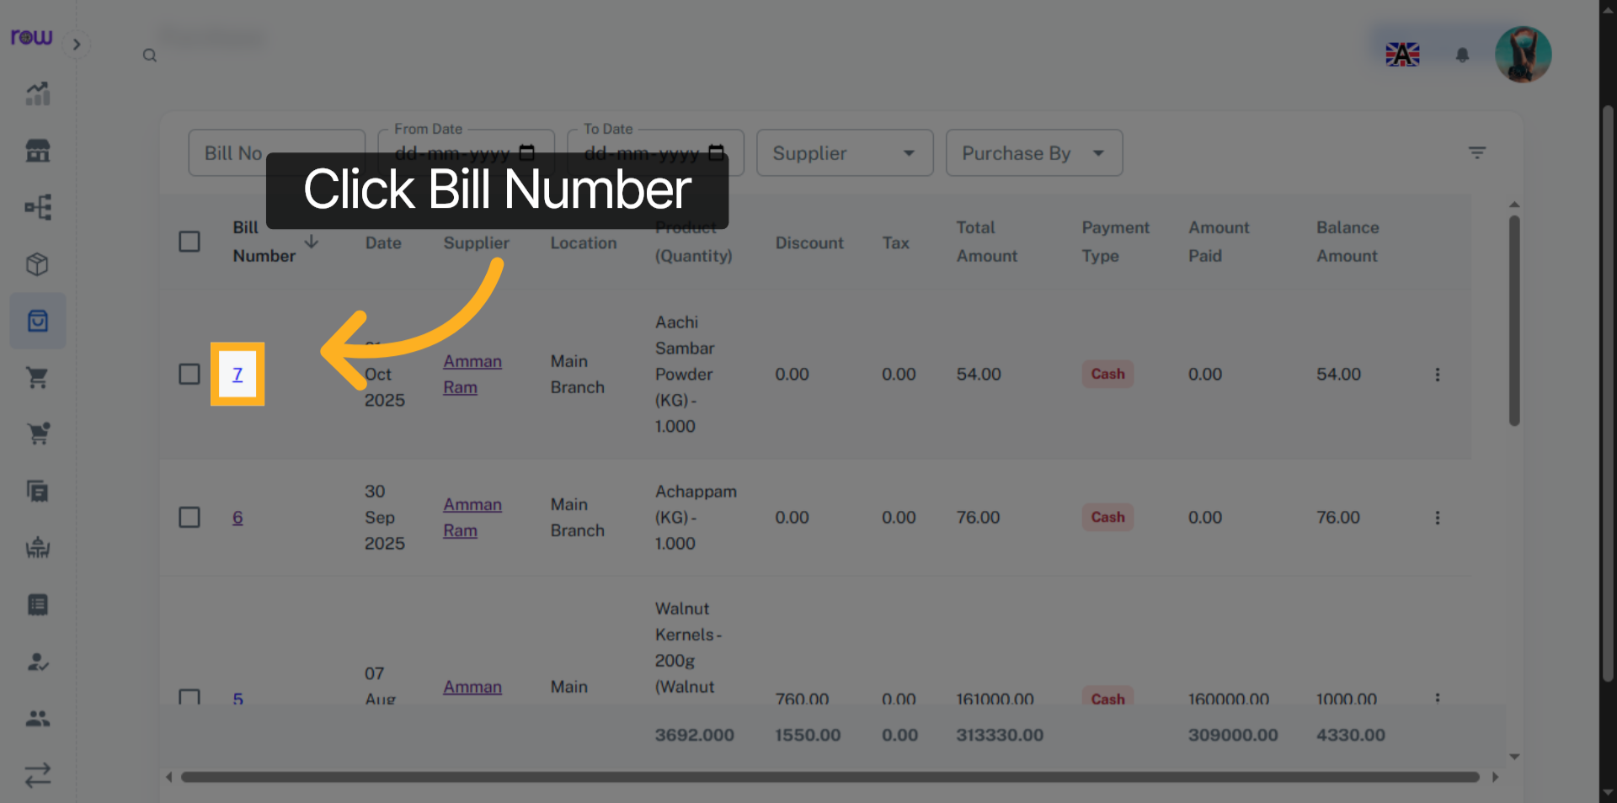

21. Edit Purchase
You can change all the fields except the Supplier, Location and products.
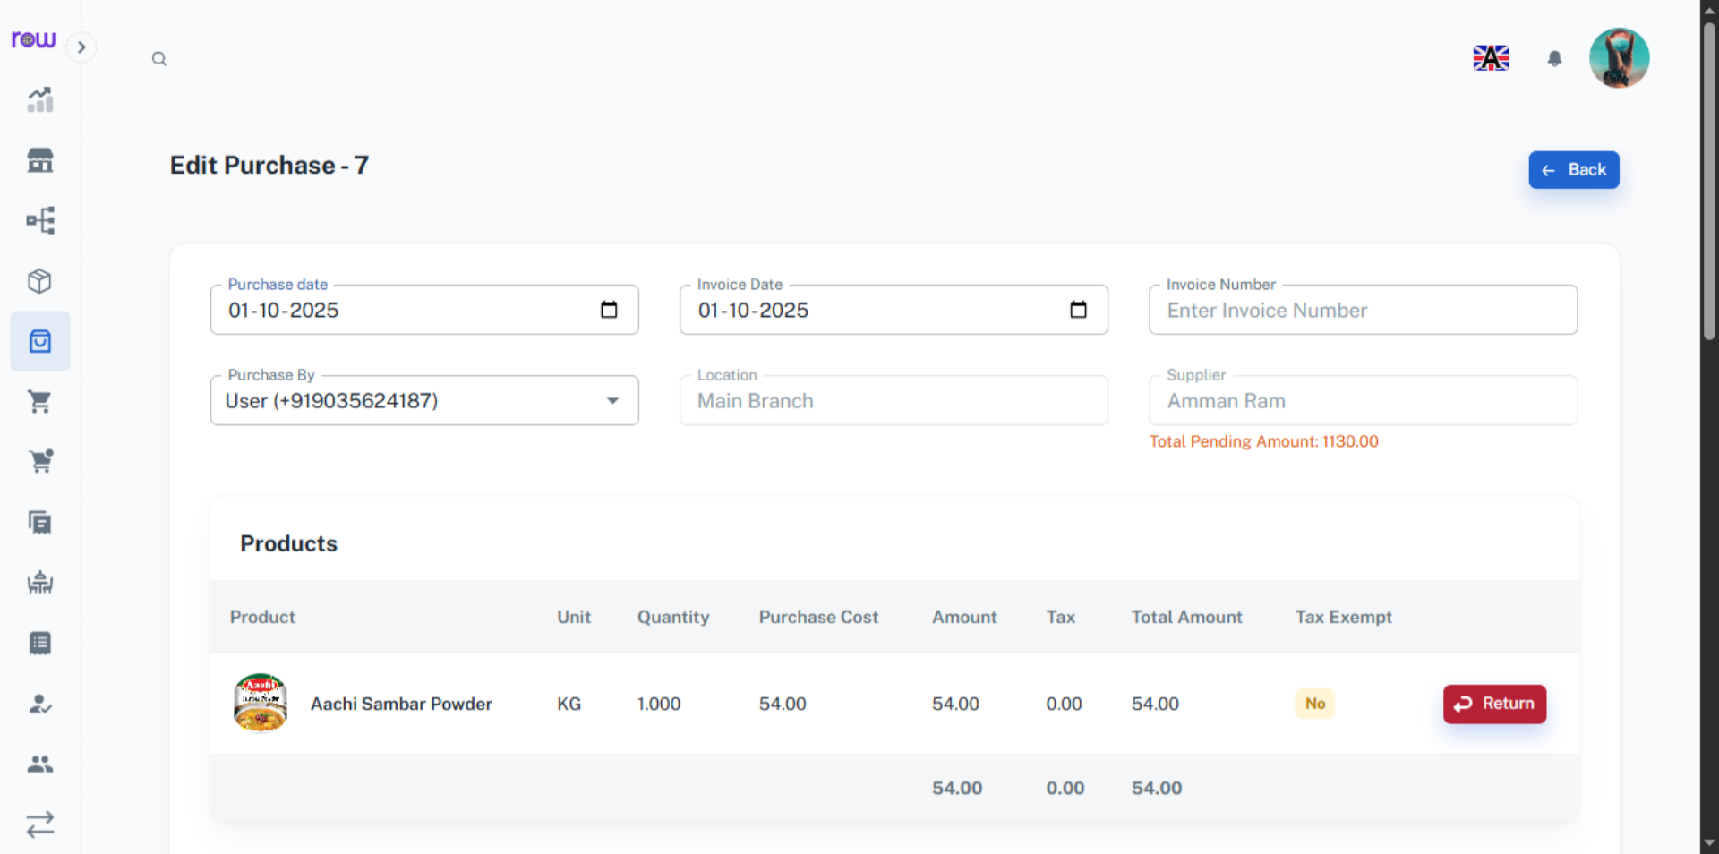

22. Return a Product
Click the Return button if wants to return a product.
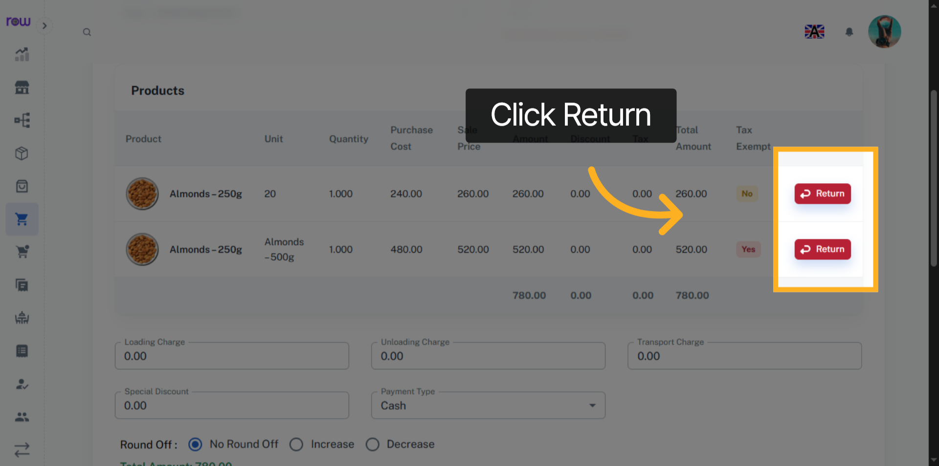

23. Add Pending Amount
Enter the pending amount received from the Supplier and click add amount button to update the amount received
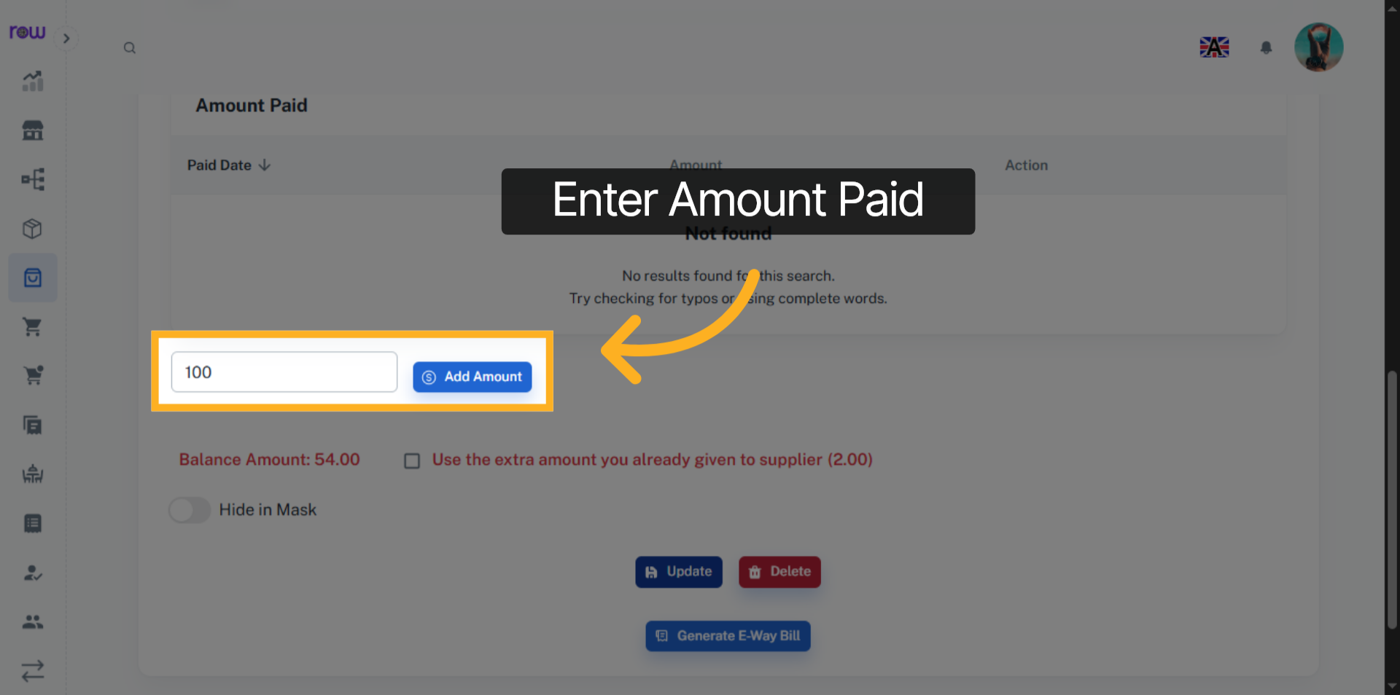

24. Update Purchase
Click Update to save the changes.
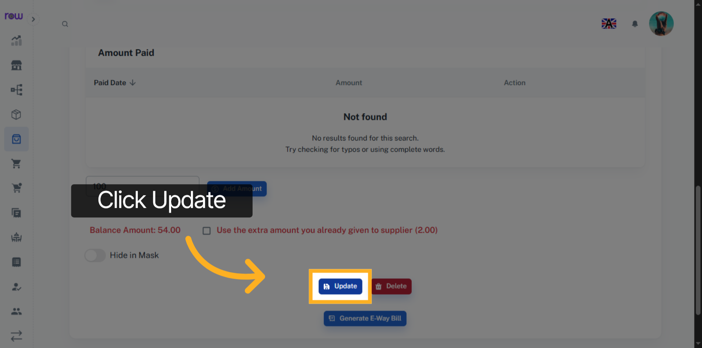

25. Delete Purchase
Click the Delete button to cancel the Purchase.
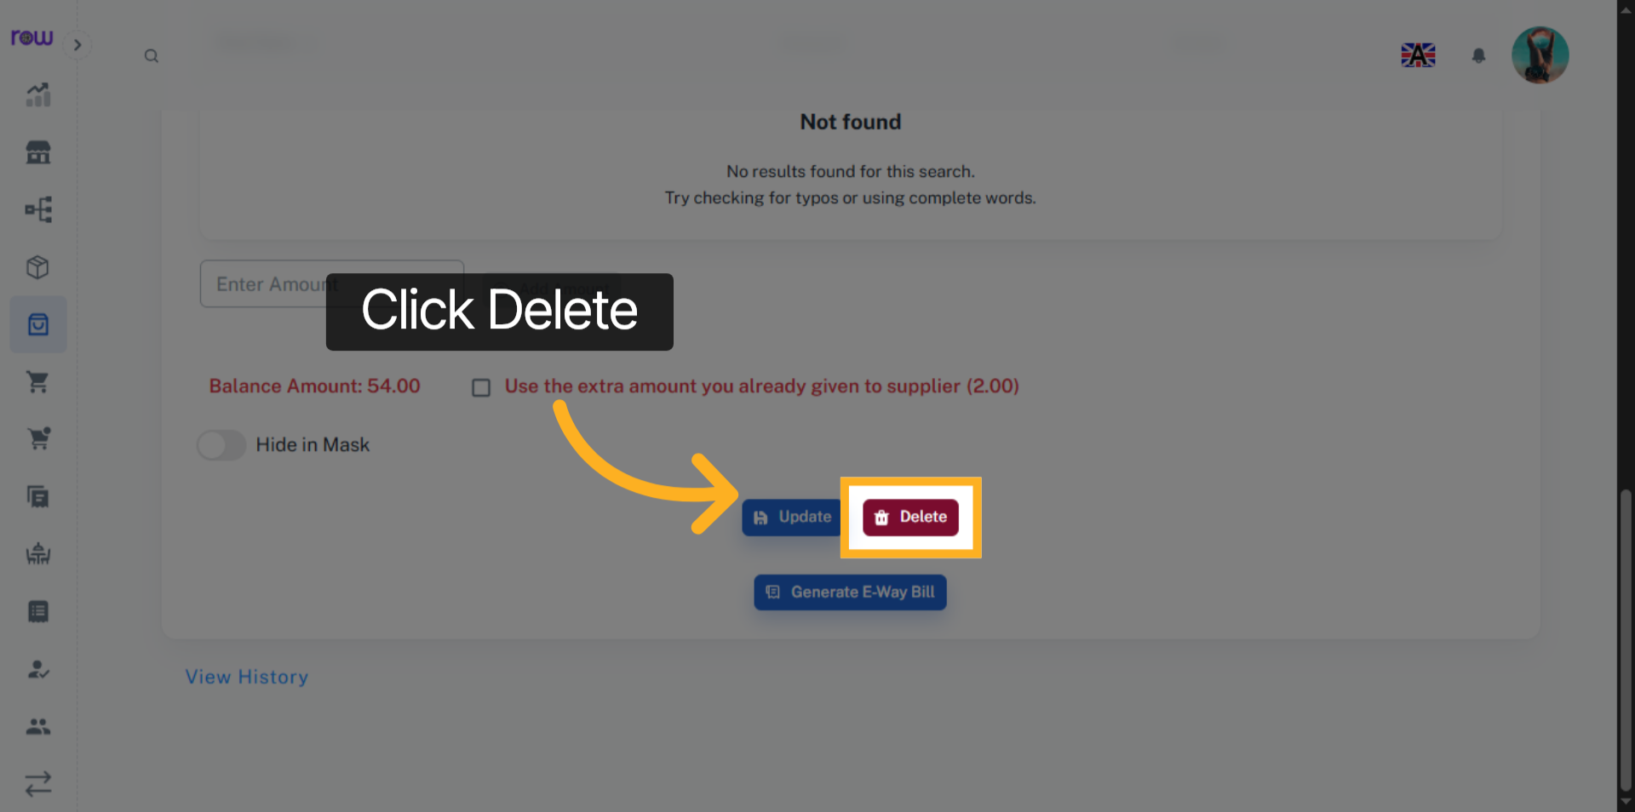

26. Generate E-way Bill
Click this button to Generate E-Way Bill.
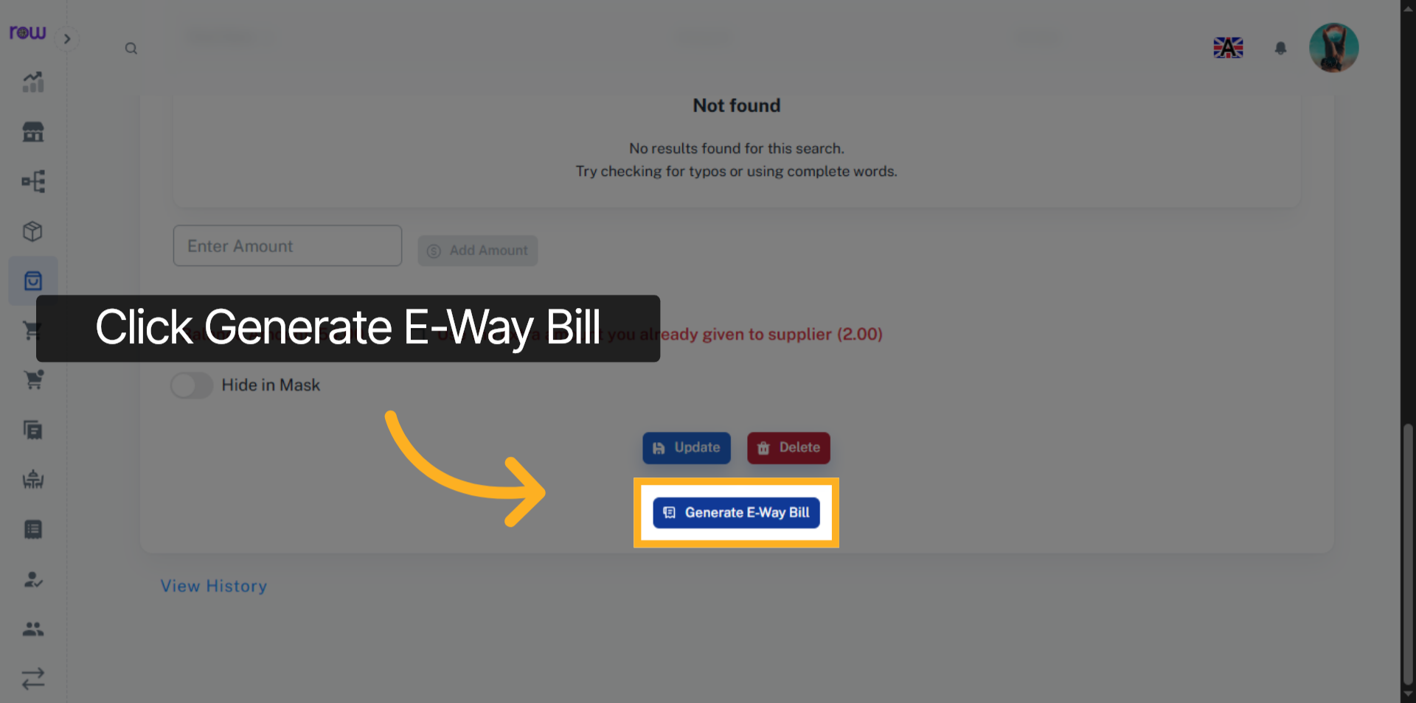

27. E-Way Bill
Please enter the transportation details if you have selected an e-way bill.
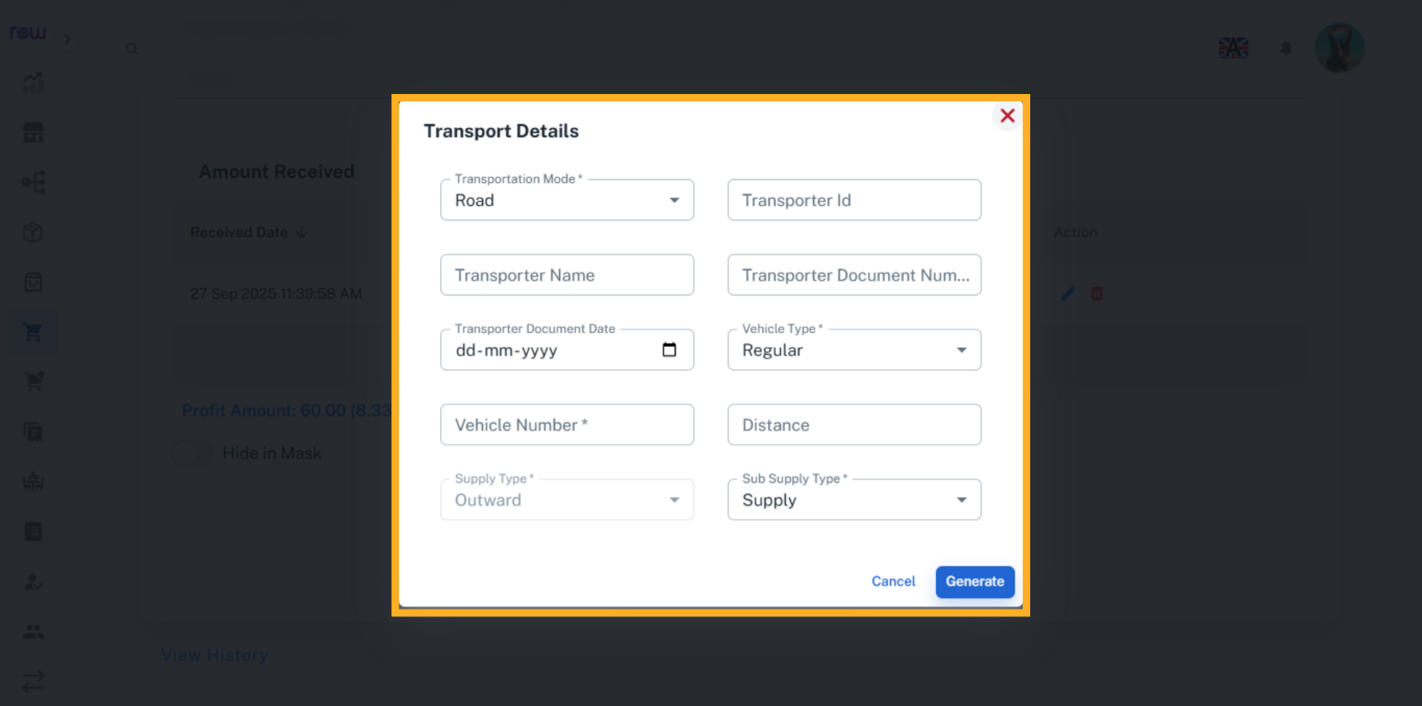

28. View History
Click the View History link to see the work history of this Purchase performed by the employees.
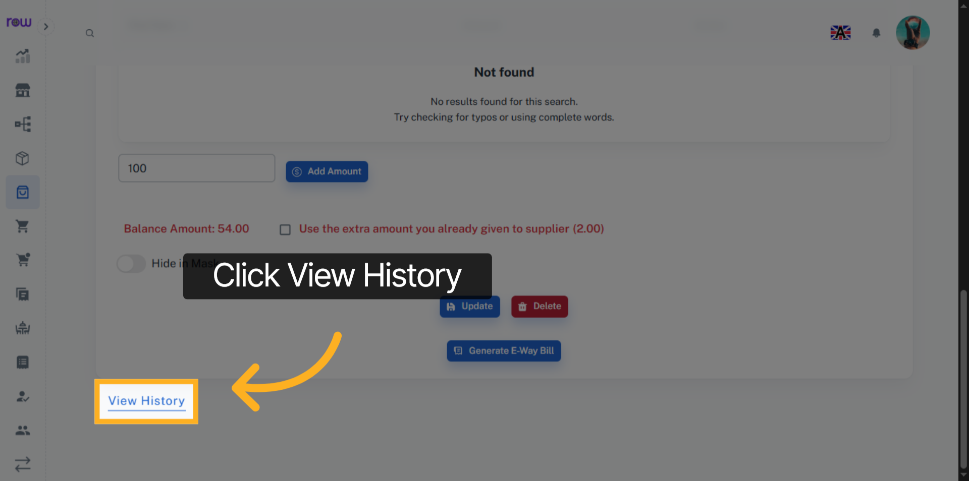

29. History
You can see who performed which actions and when in history.
