Create and Manage Quotations and convert to Sales, Order & Invoice in RunOnweb

Go to runonweb.com

1. Introduction
In this tutorial, you will learn how to create, update, and cancel a quotation, as well as how to convert a quotation.

2. Quotation Menu
Select the Quotation menu to open the Quotation list screen.
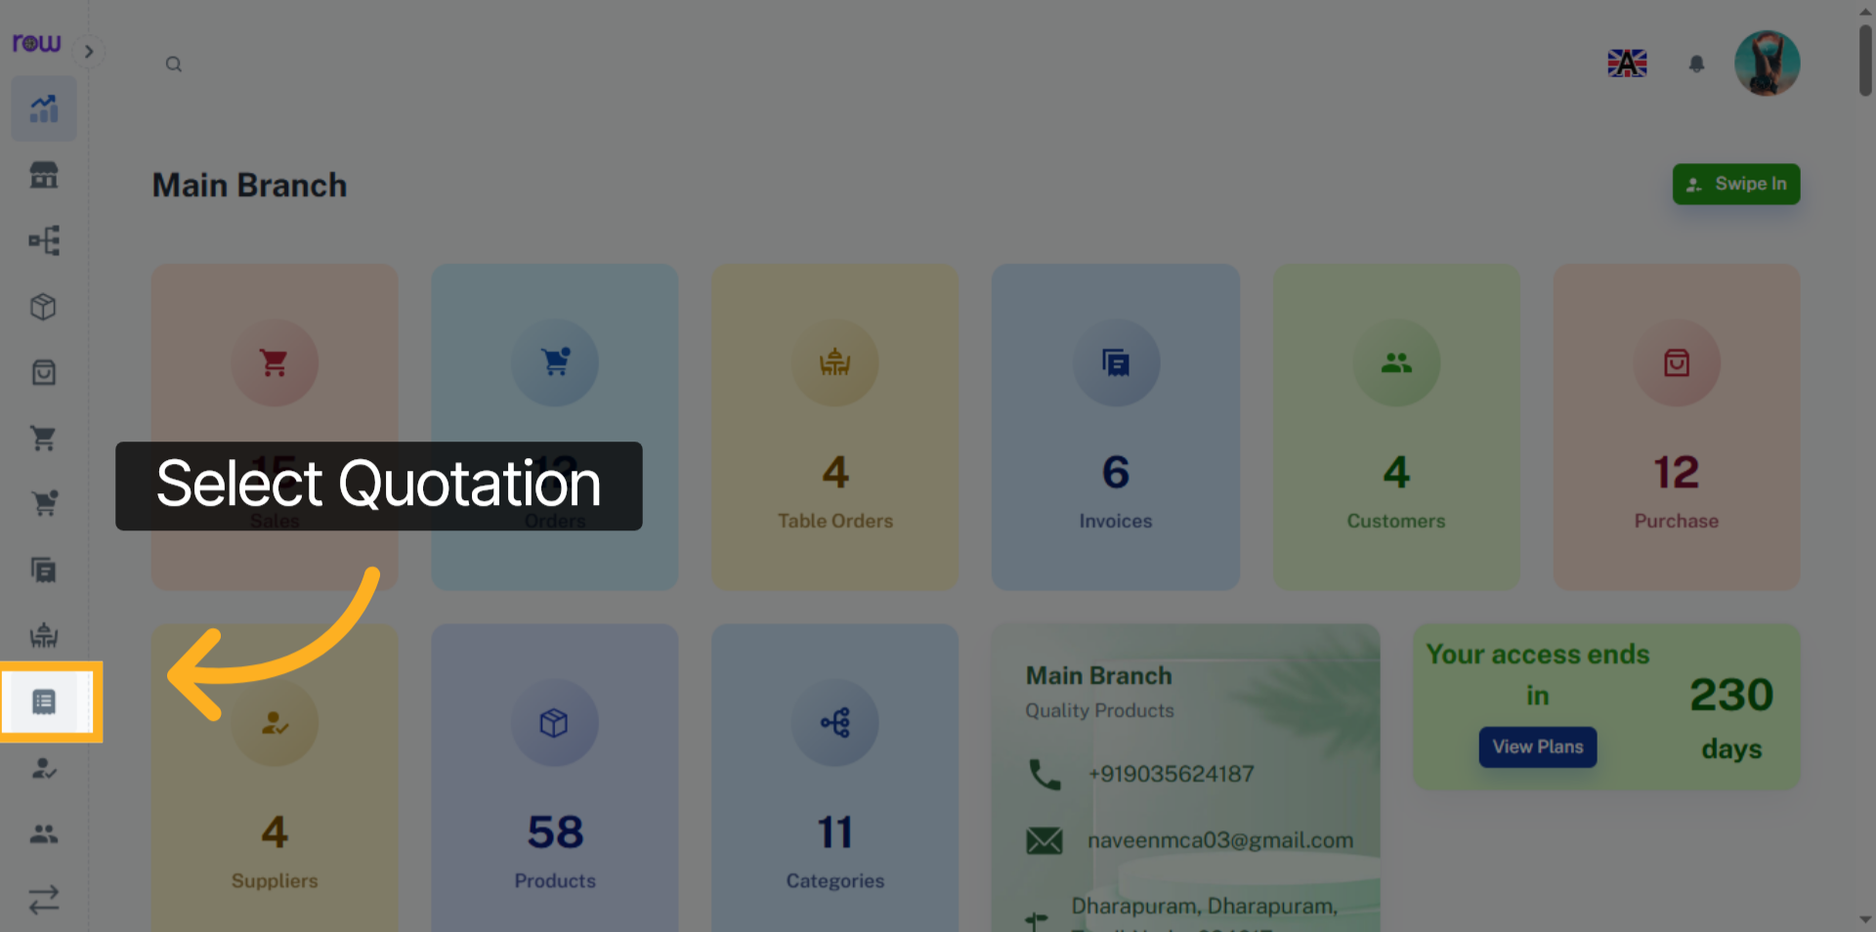

3. New Quotation Button
Click the New Quotation button to start creating a Quotation.
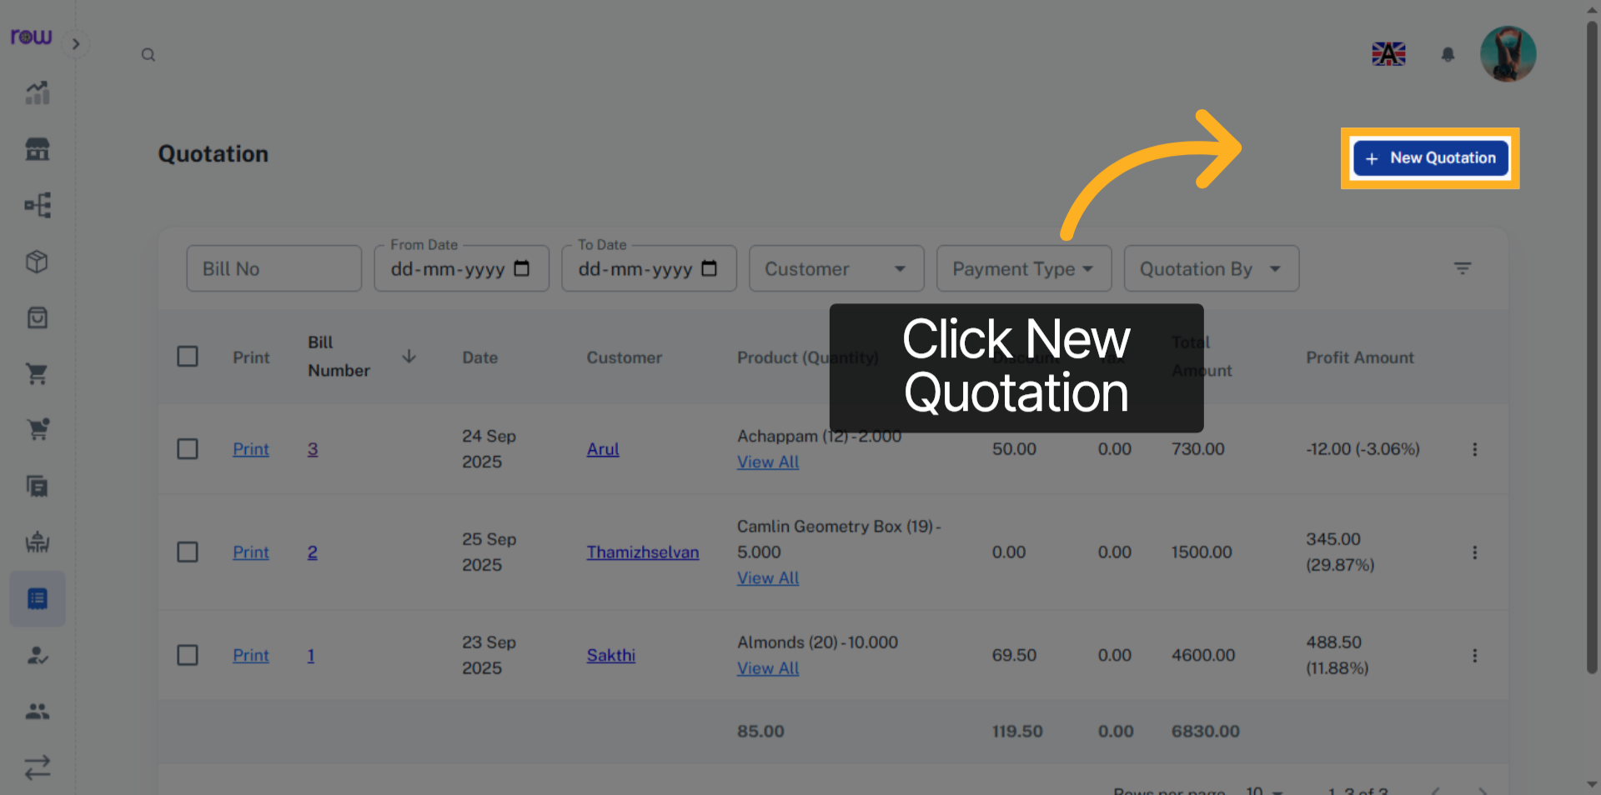

4. New Quotation
Date, Quotation by are already filled in. You can update them if needed.
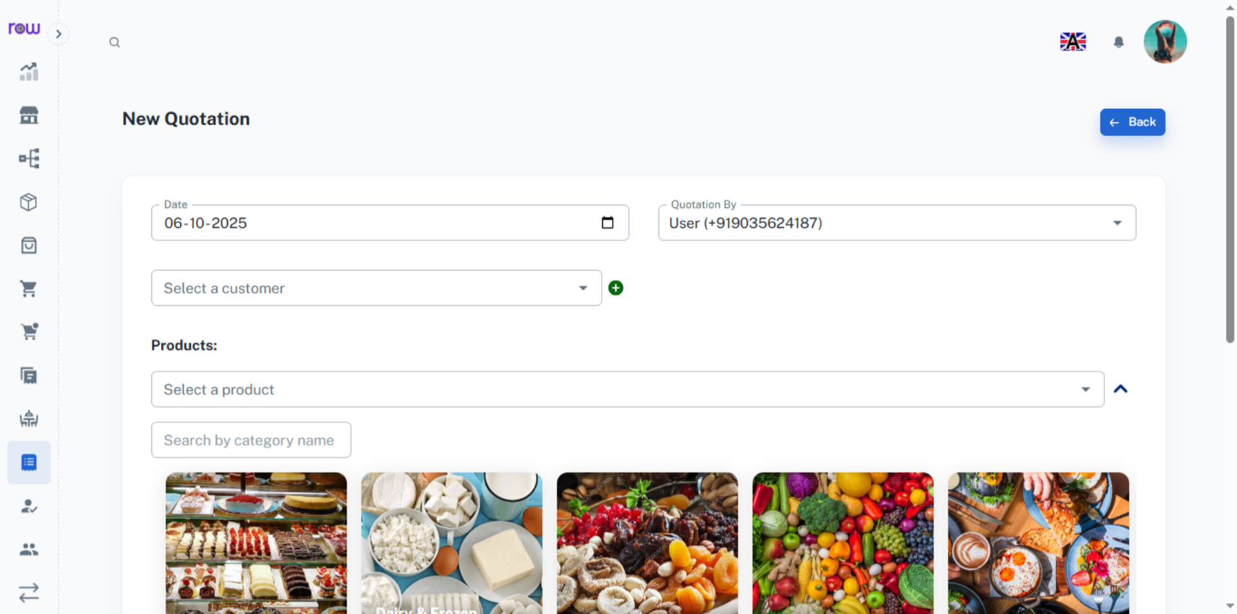

5. Select a customer
Search and select an existing customer.
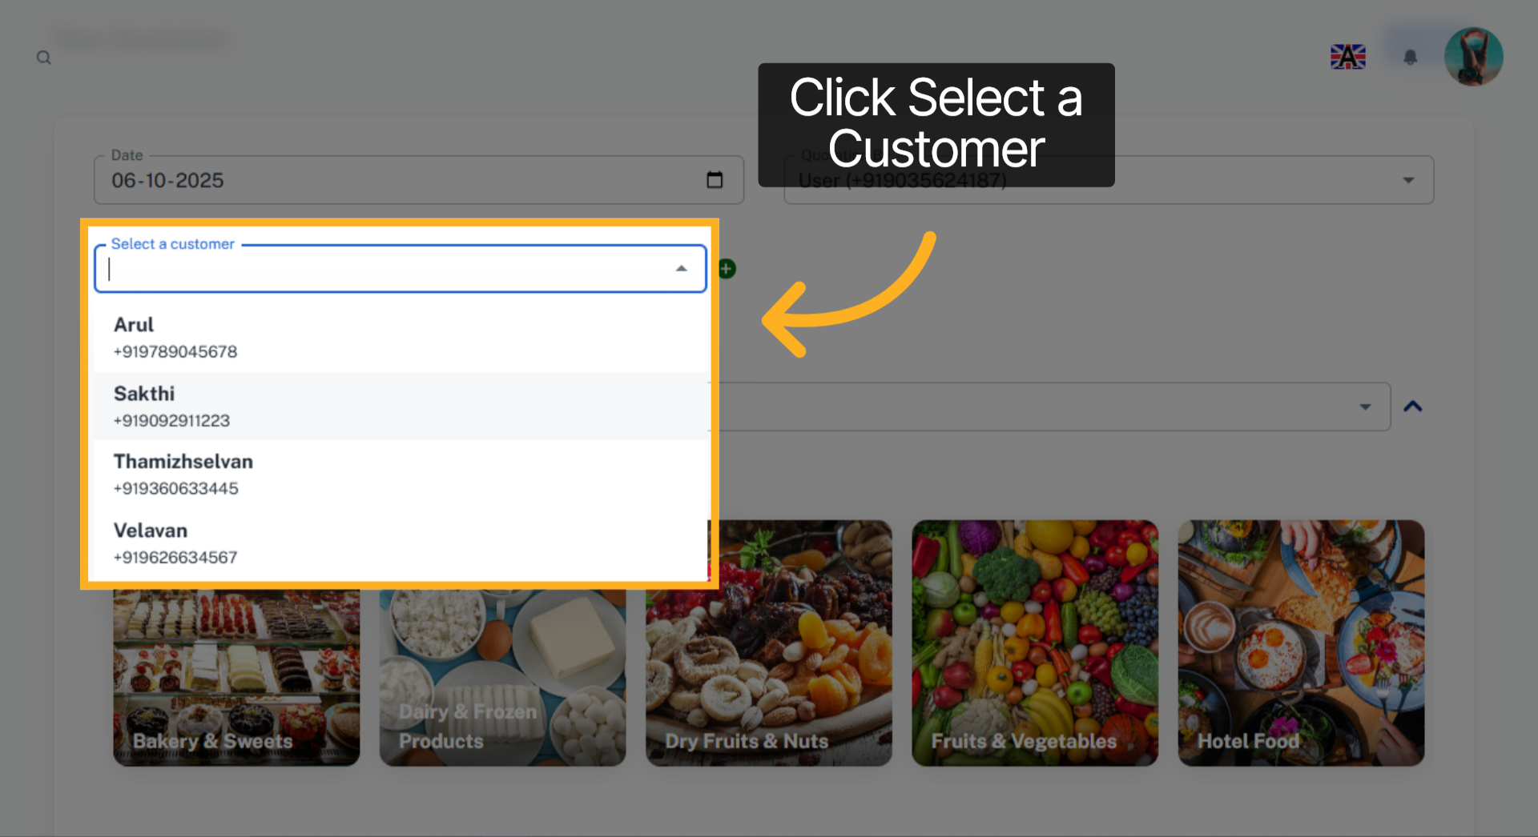

6. Create new customer
Click + icon to add a new customer
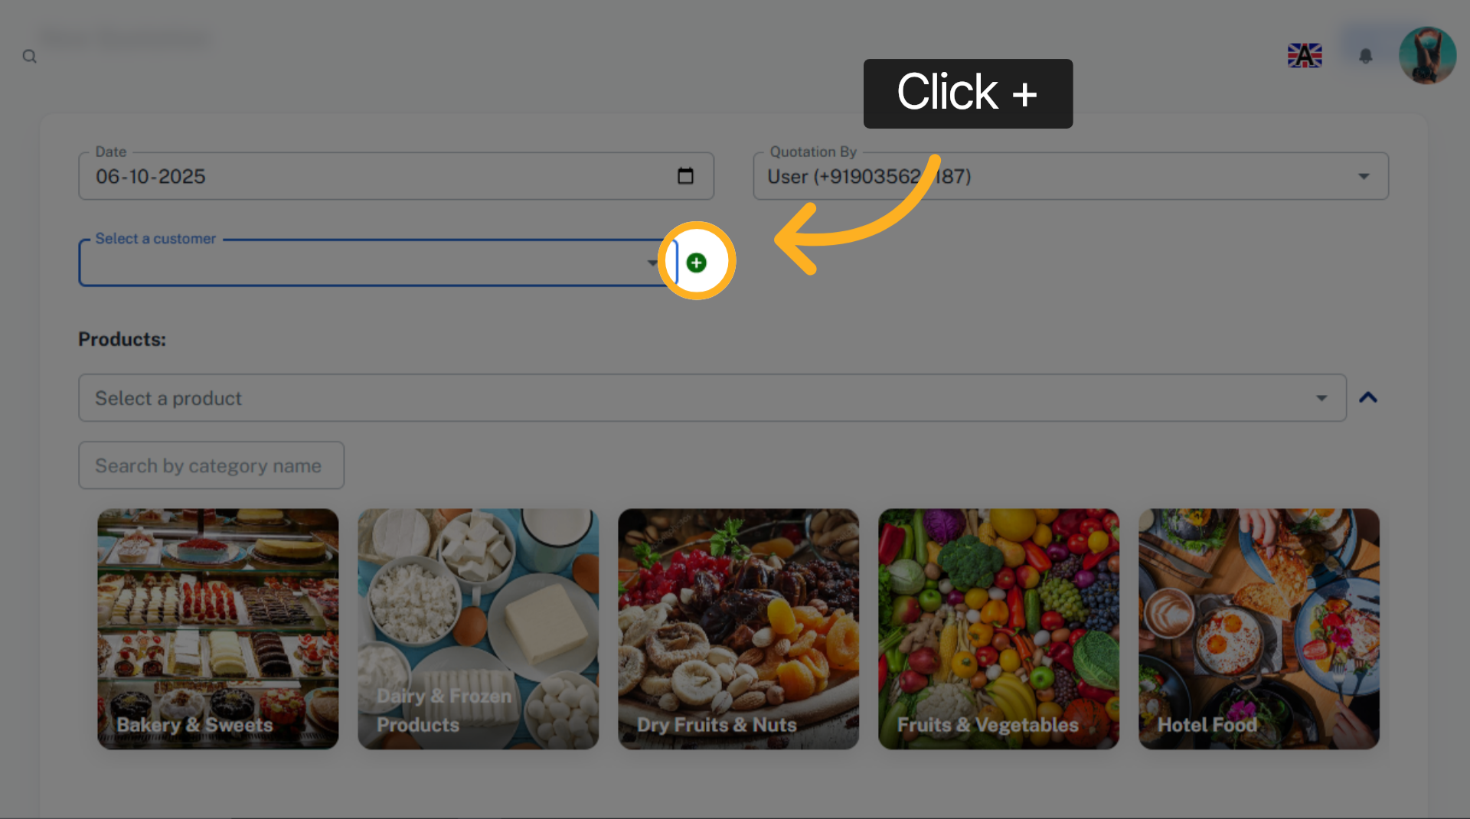

7. New Customer Page
Enter the new customer details and click Add to save and select the customer.
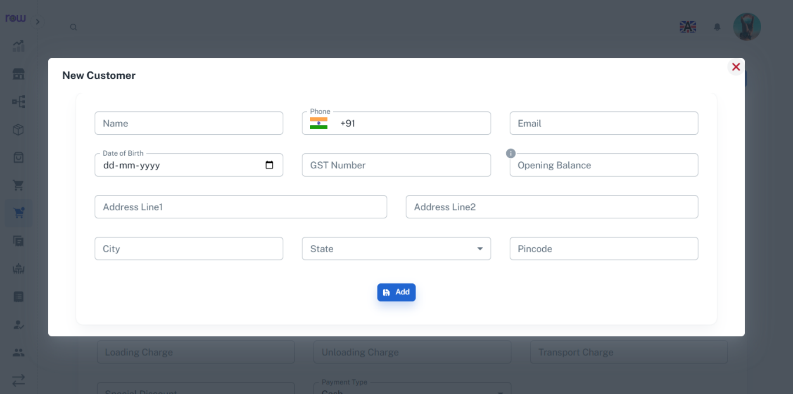

8. Select a product
Select a product from the dropdown. You can search by product name or code.
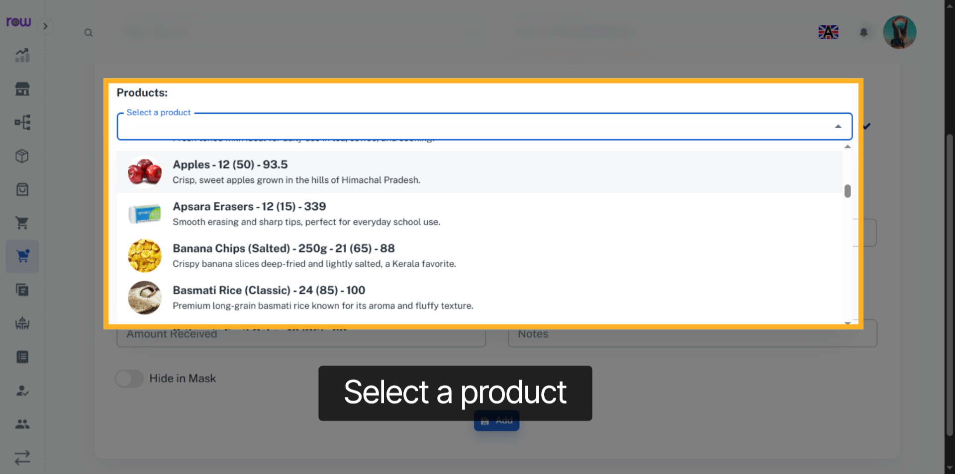

9. Product Selection Dropdown
Or click the arrow to find a product by its category.
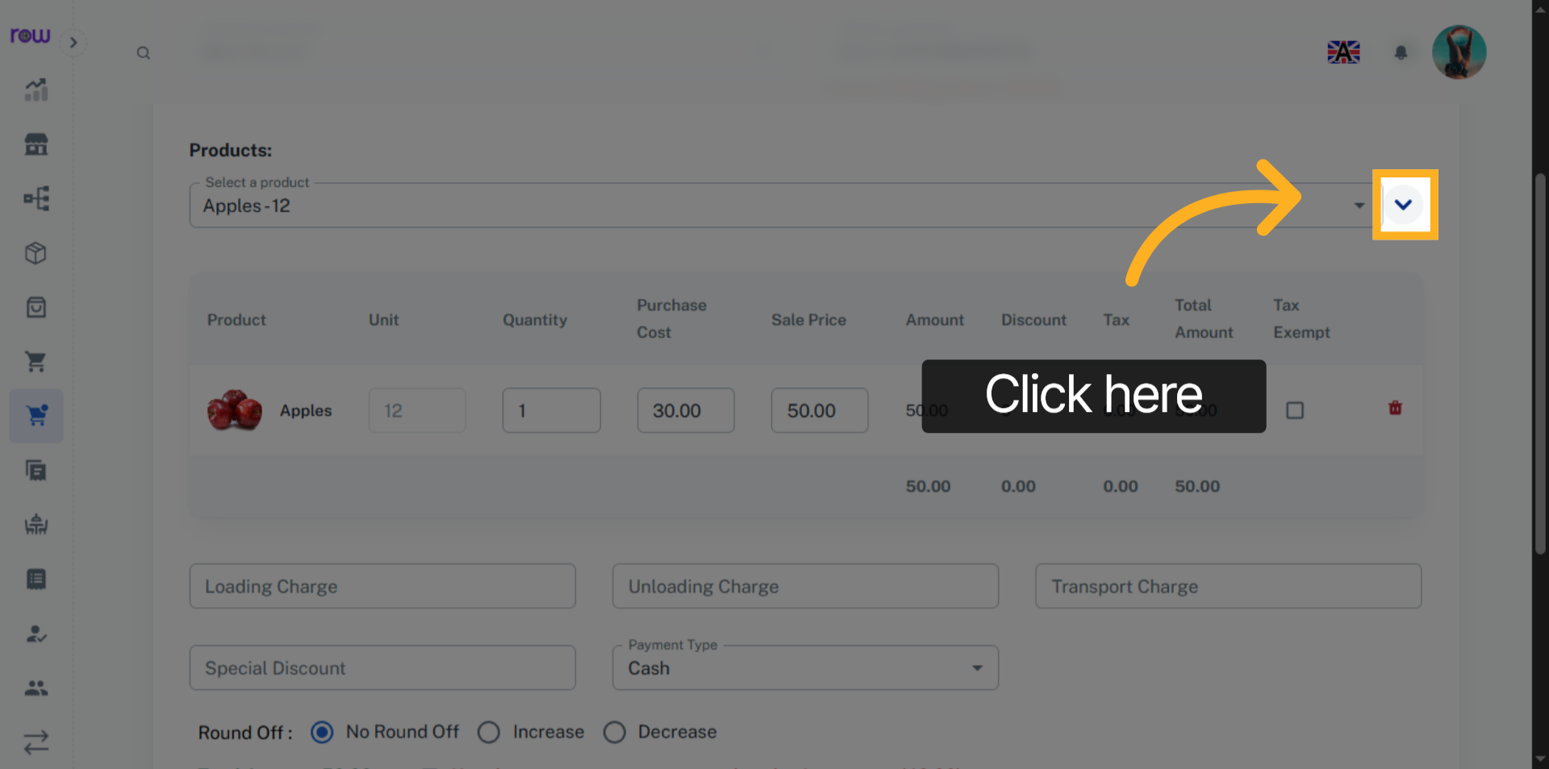

10. Select the product category
select the product by its category
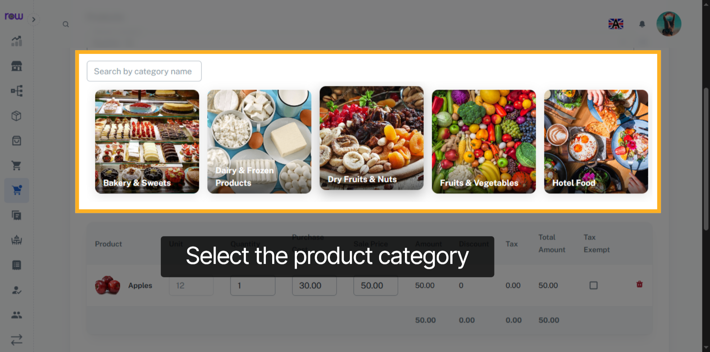

11. Select Product
Select Product
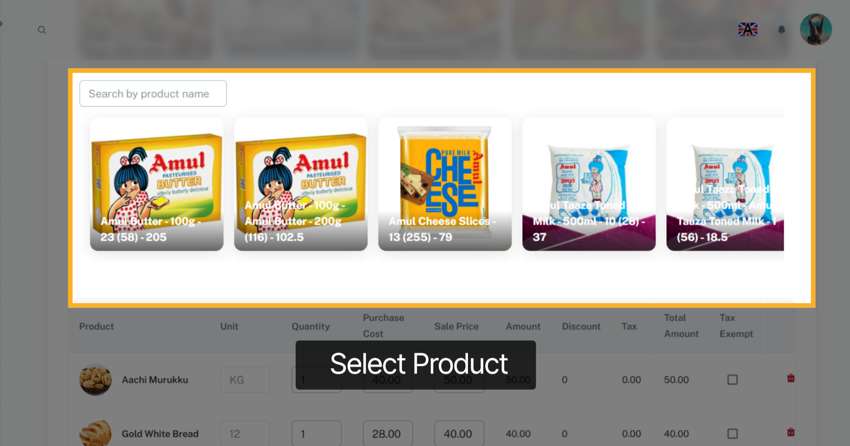

12. Selected Product List
After product selection you can update the quantity, Purchase cost and Sale price of the products.
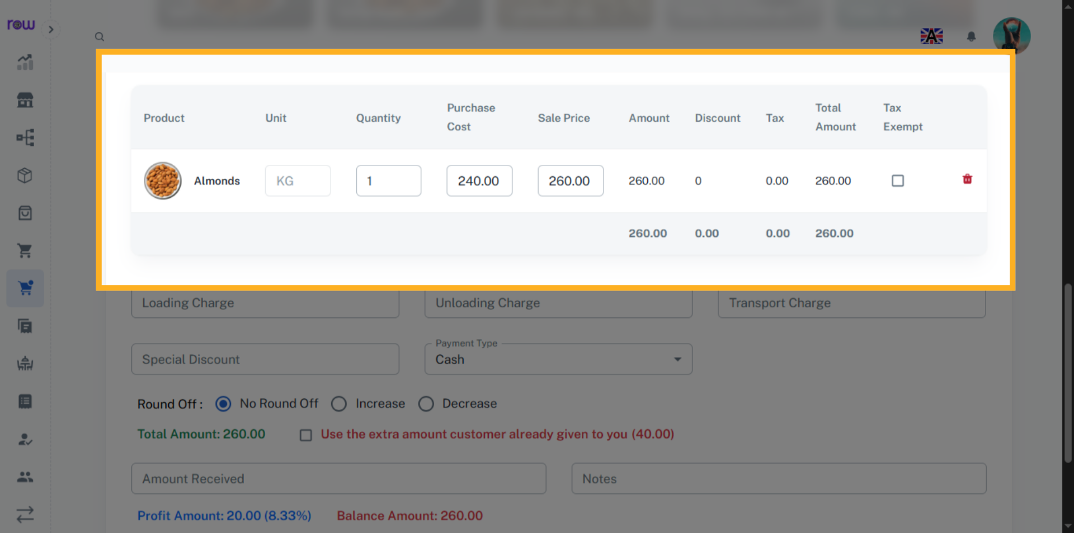

13. Tax Exempt Checkbox
Select the checkbox to exempt the tax for a product.
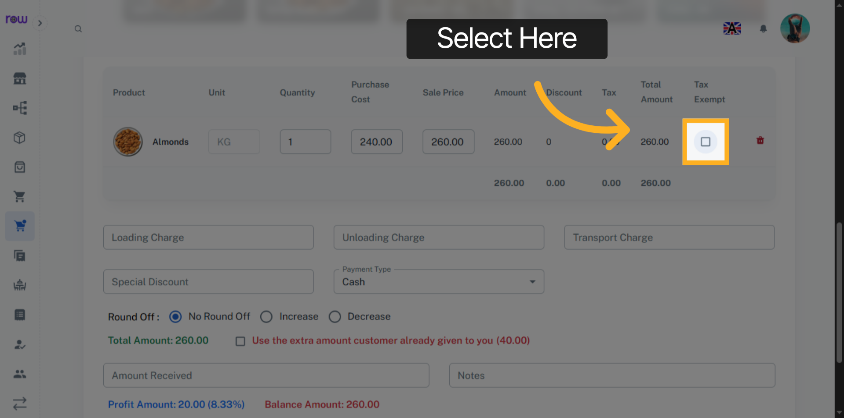

14. Other Optional Fields
Enter loading charge, unloading charge, transport charge and Special discount if applicable.
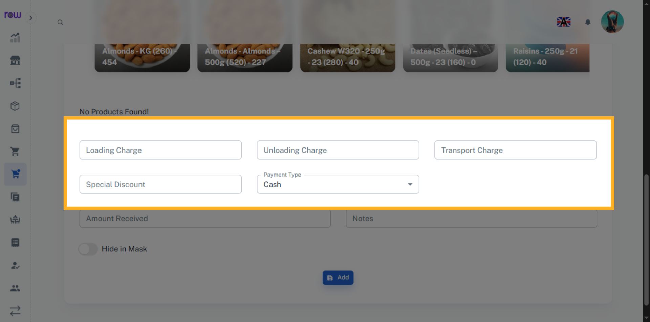

15. Round Off
If the total value has decimal points, you can round it off.
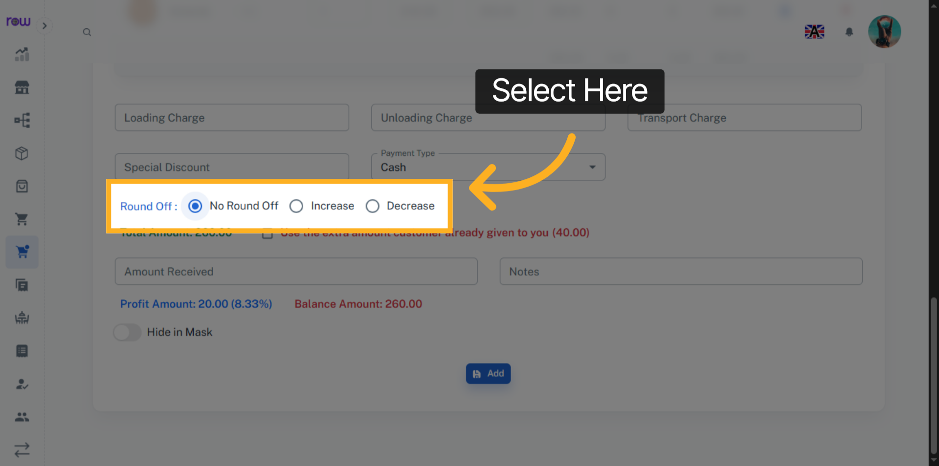

16. Amount Received
Enter the amount received from the customer
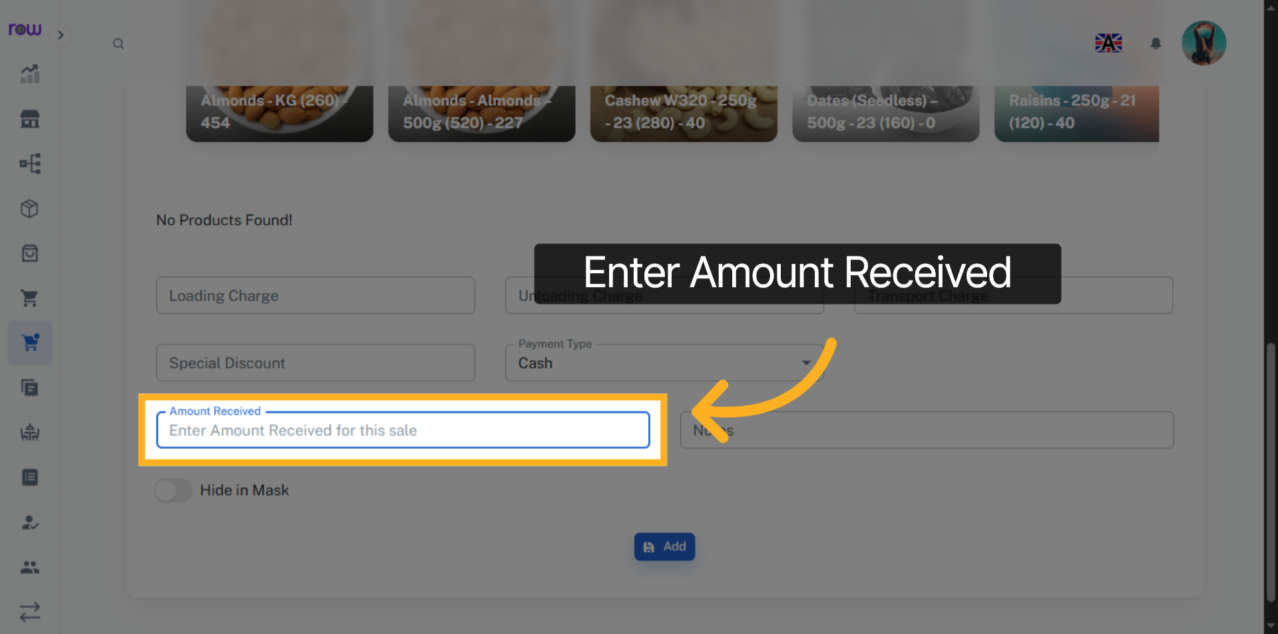

17. Add
Click "Add" to create the Quotation
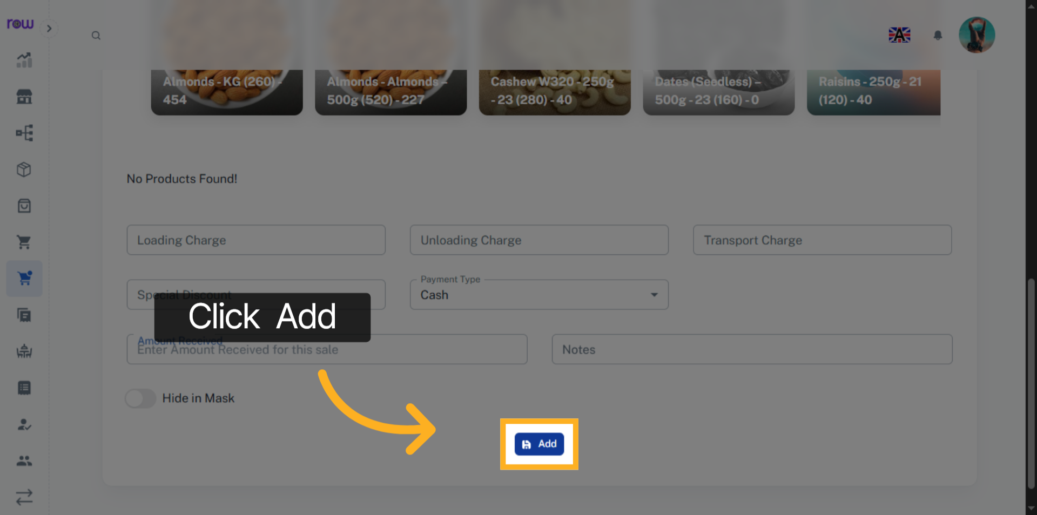

18. Quotations list
You will be redirected to the Quotation list screen after the Quotation is successfully created.
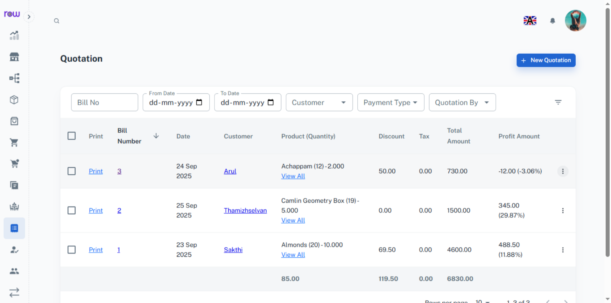

19. Quotation Conversion
Click here to View the list of Actions.
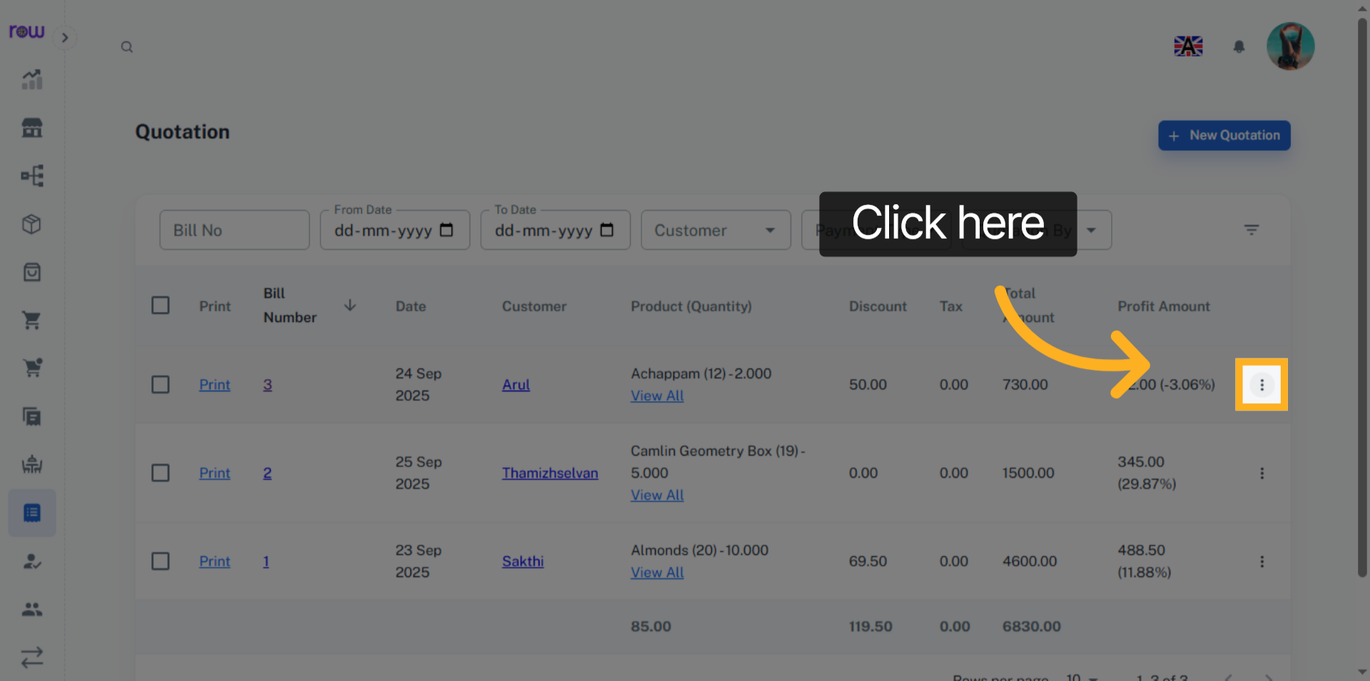

20. Conversion List
You can convert this quotation into a sale, order, or invoice as per your requirements.
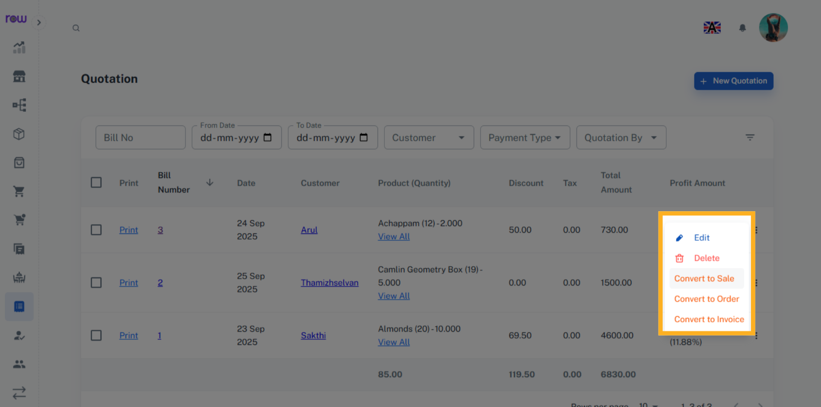

21. Approve Conversion
Click "Yes" to confirm and approve the conversion.
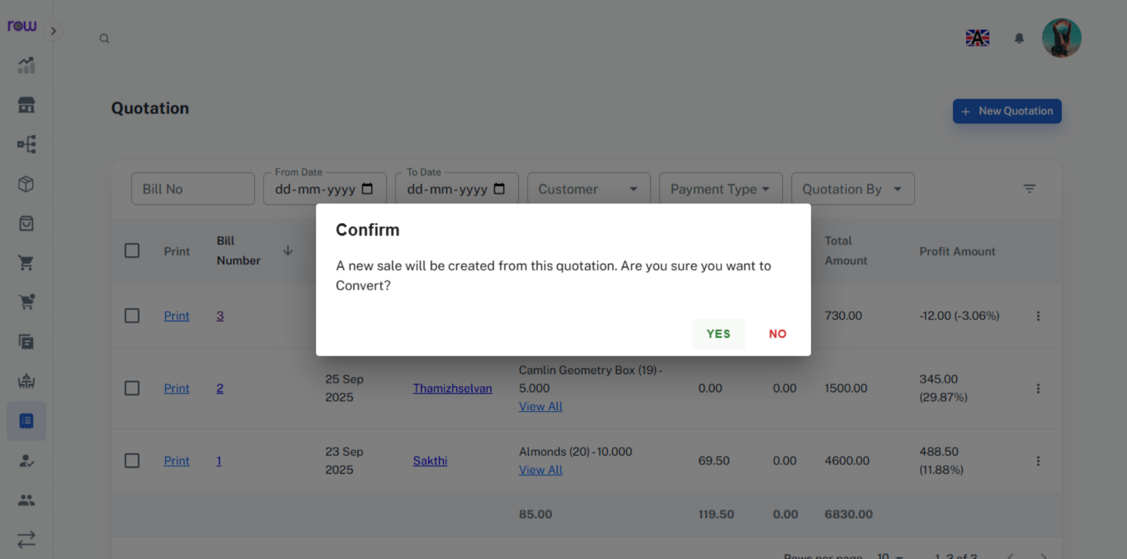

22. Navigation
Click "Go To" to view the details of the newly created sale, order or invoice.
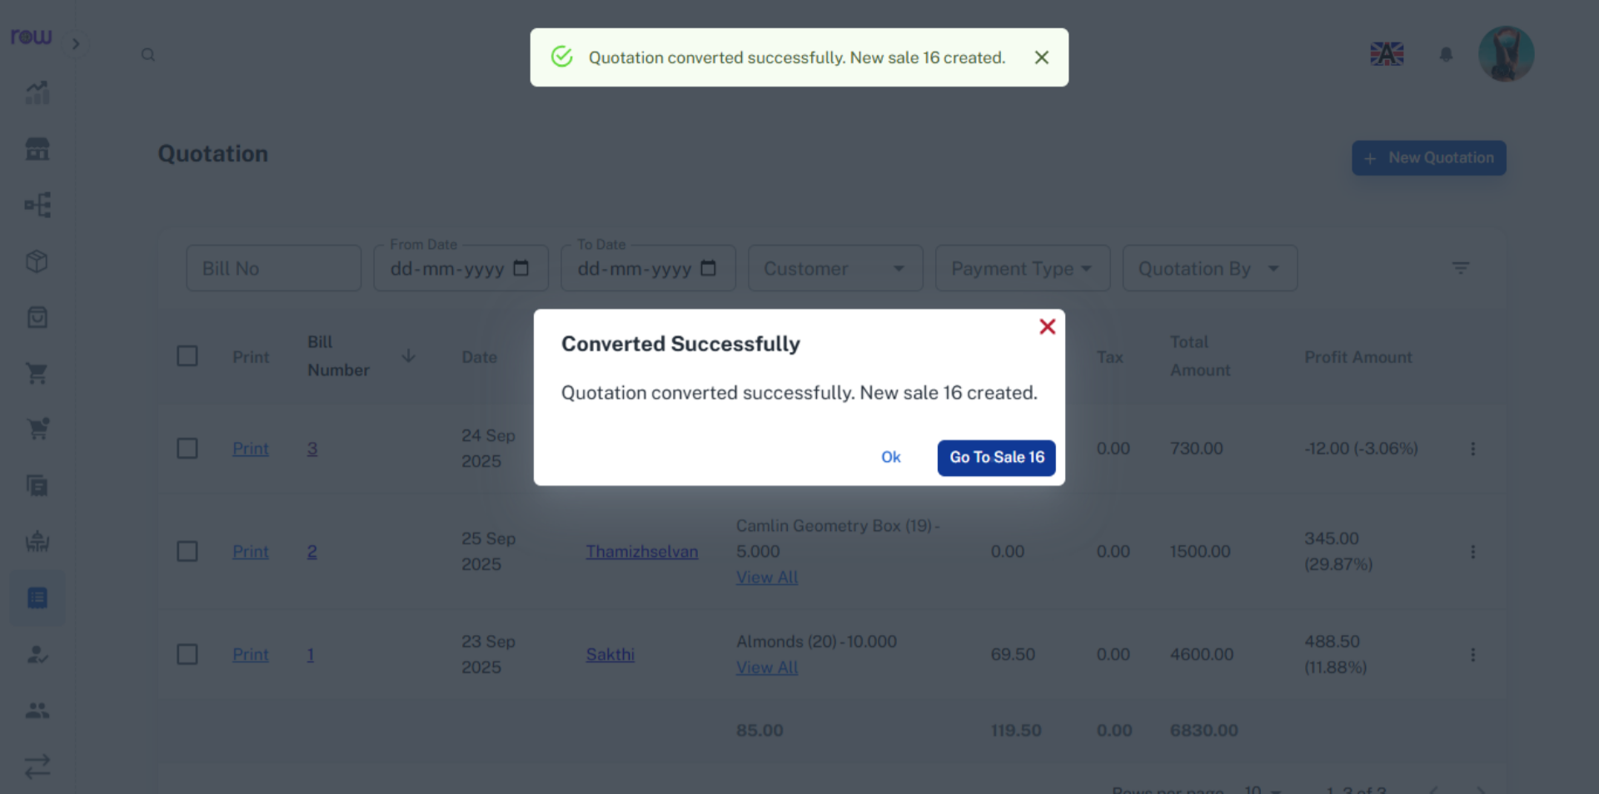

23. Converted Quotation
The quotation number is displayed at the top, indicating from where it was created.
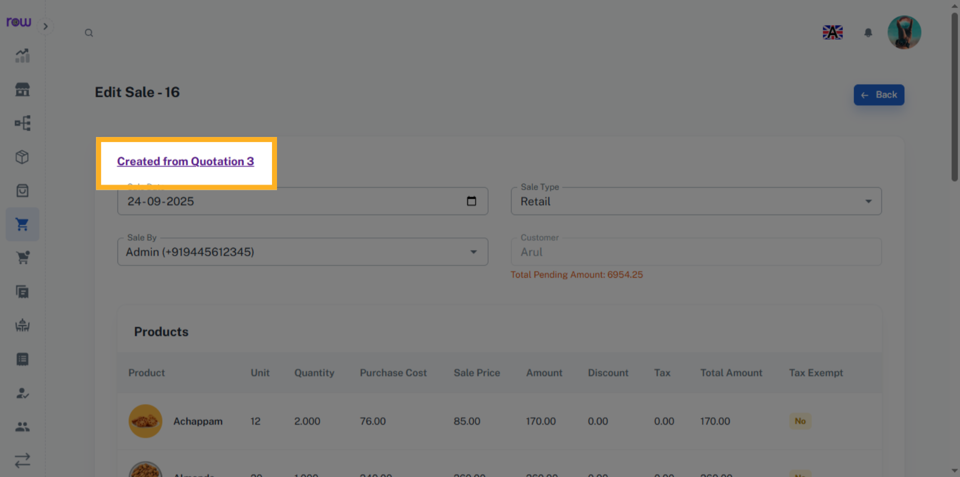

24. Bill Number
Click the bill number to edit the quotation.
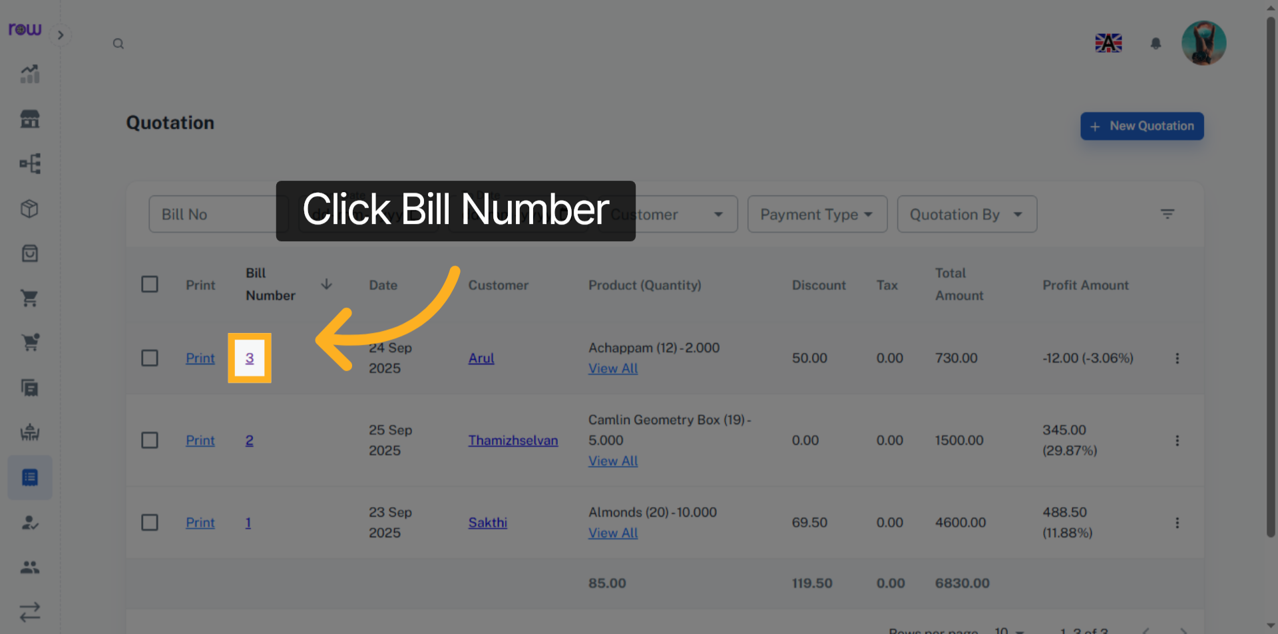

25. Edit Quotations
You may modify all fields except the customer. Additionally, you can add, update, or remove products during the update process.
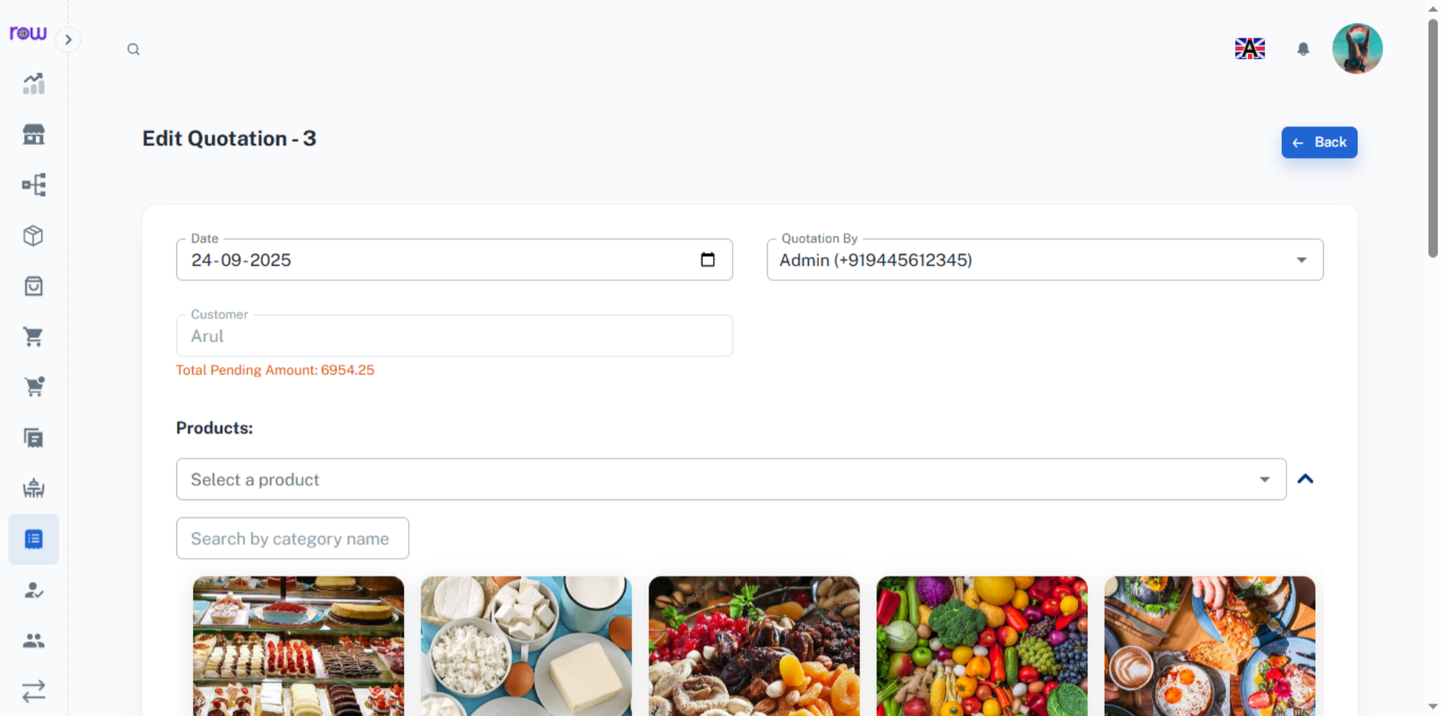

26. View Conversion Summary
You can view the conversion summary of a quotation.
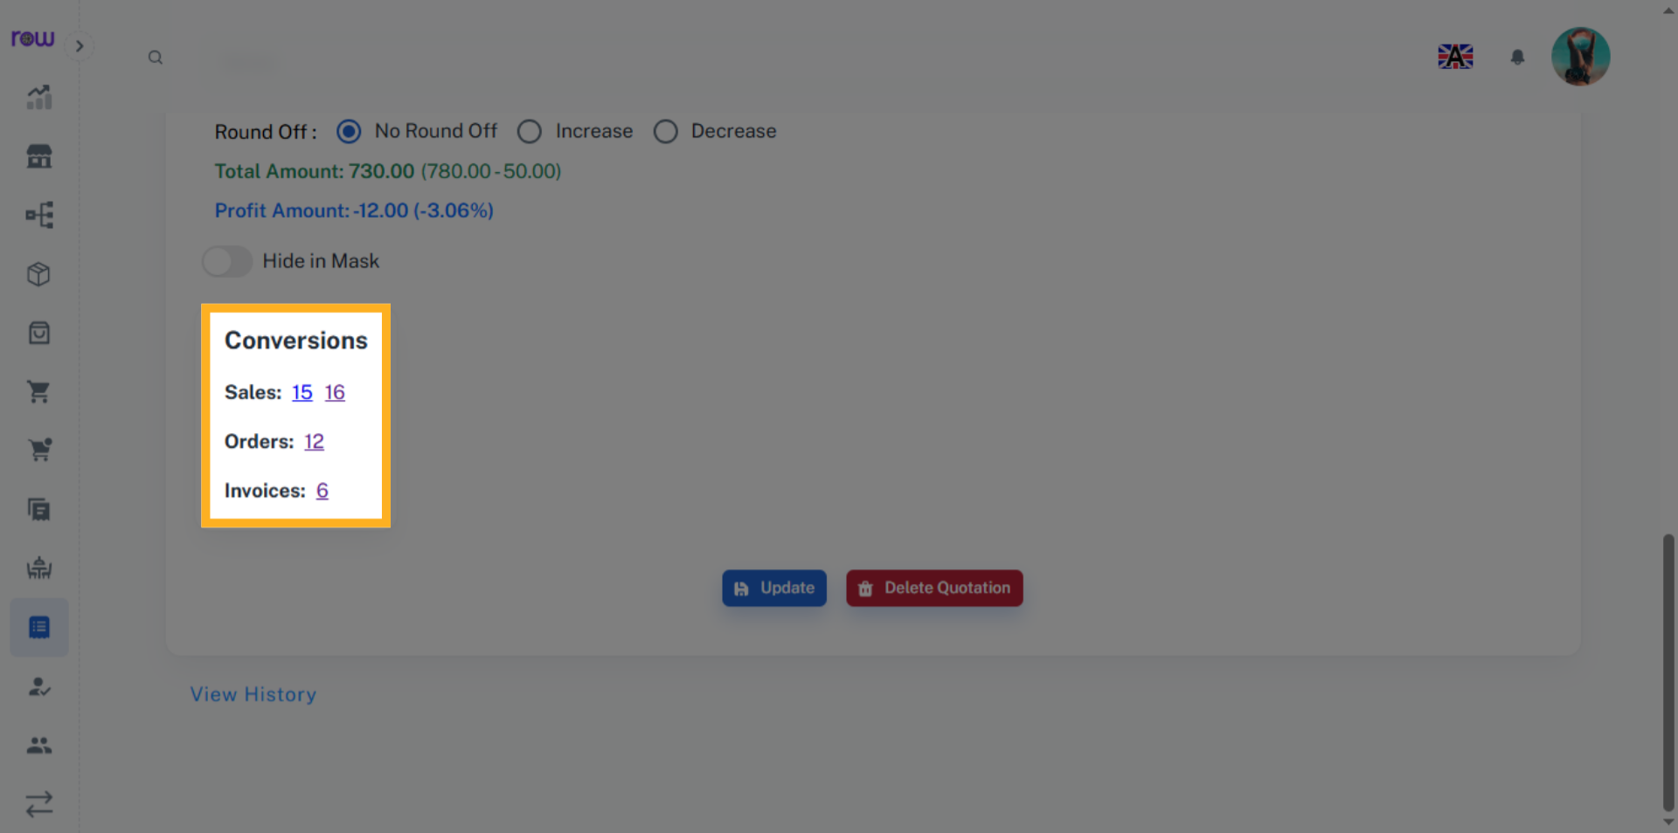

27. Update Quotations
Click Update to save the changes.
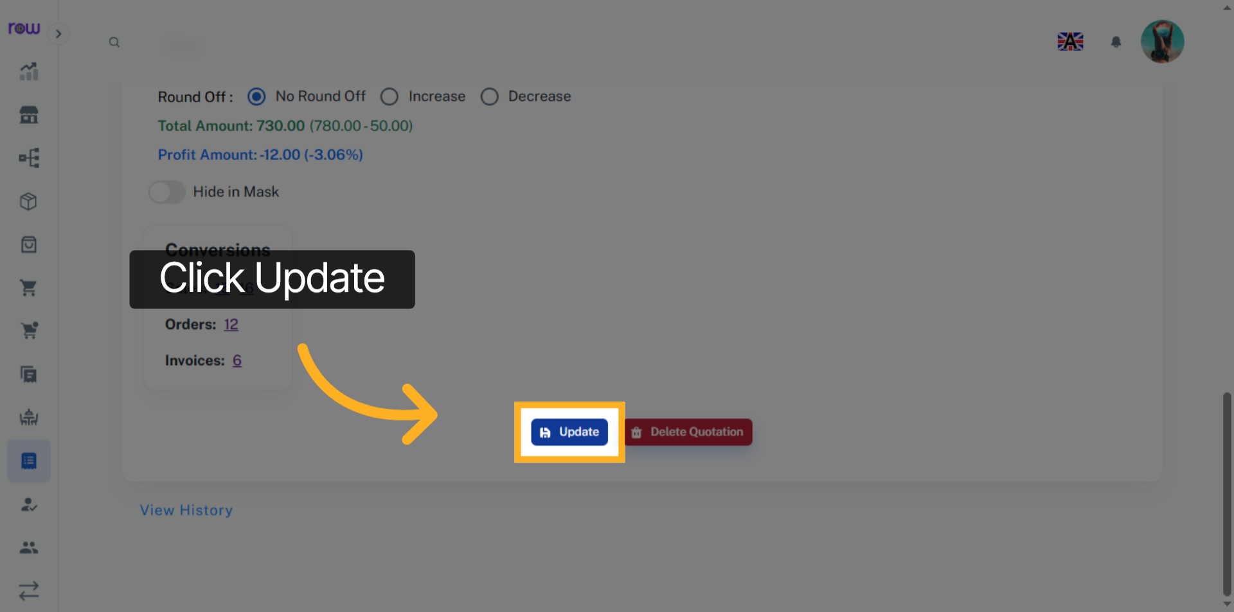

28. Delete Quotation
Click the Delete Quotation button to delete the quotation.
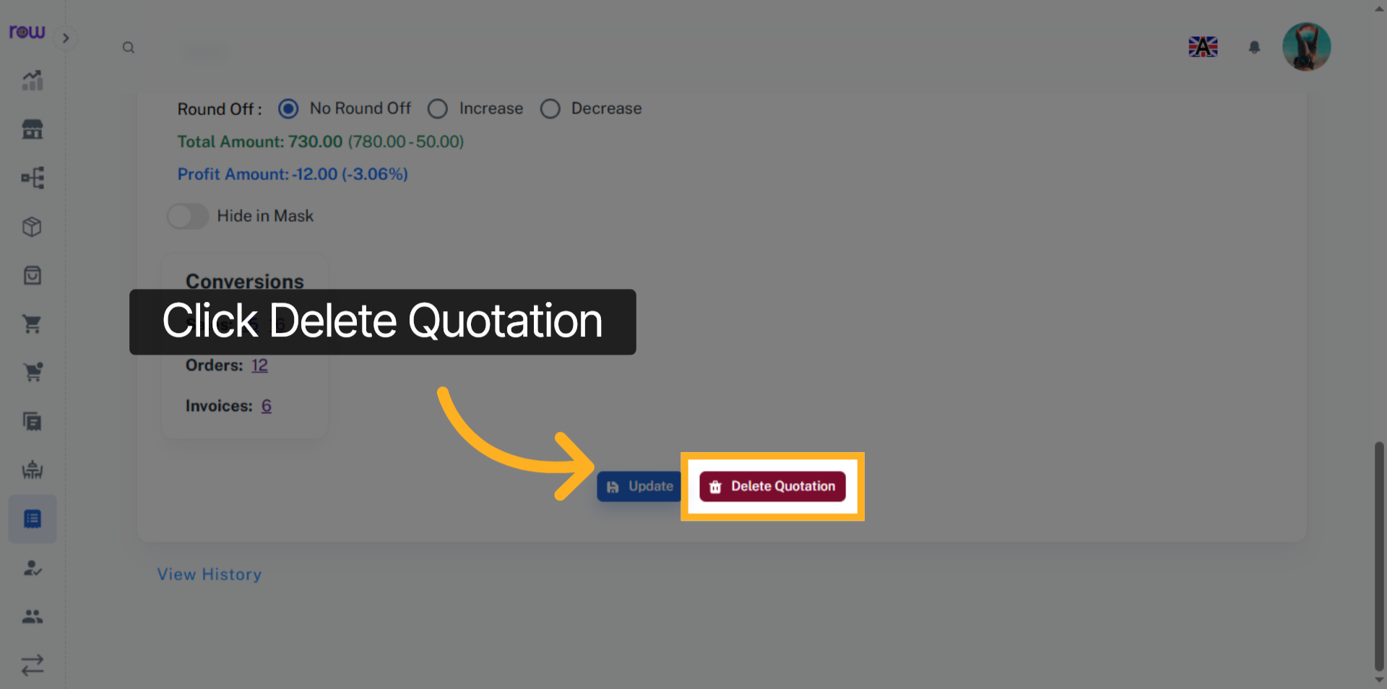

29. View History
Click the View History link to see the work history of this quotation performed by the employees.
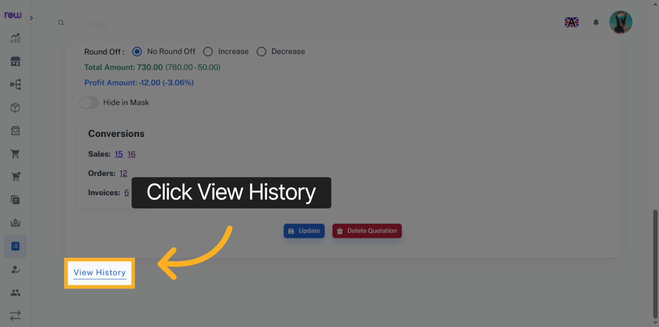

30. History
You can see who performed which actions and when in the history.
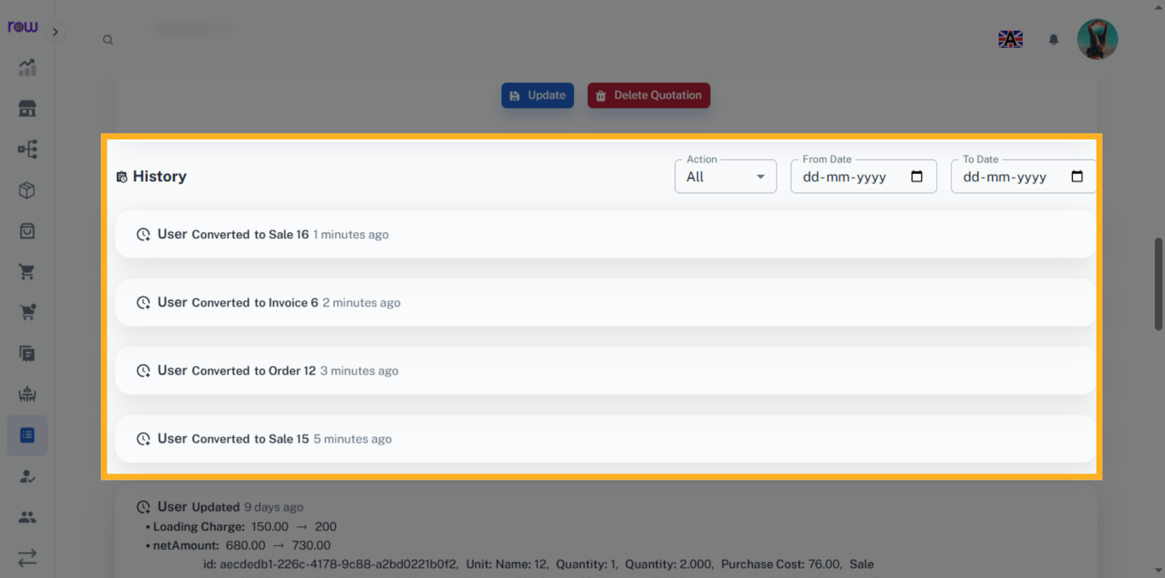

31. Print
Click Print to generate and view, the bill.
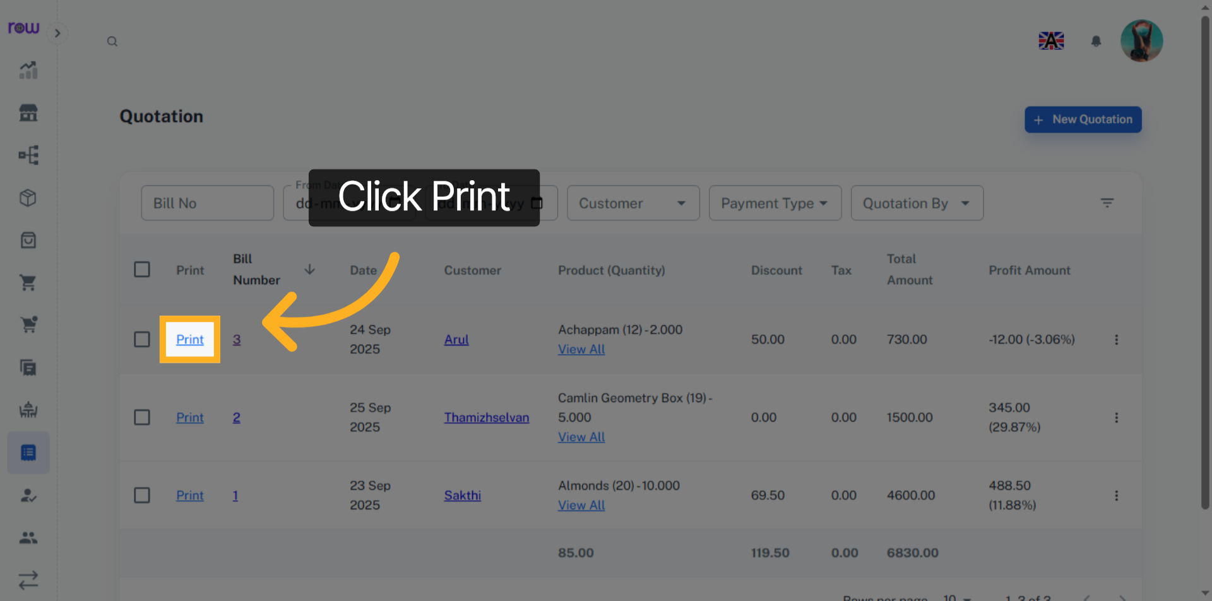

32. Download and Print Bill
You can print and download the bill.
